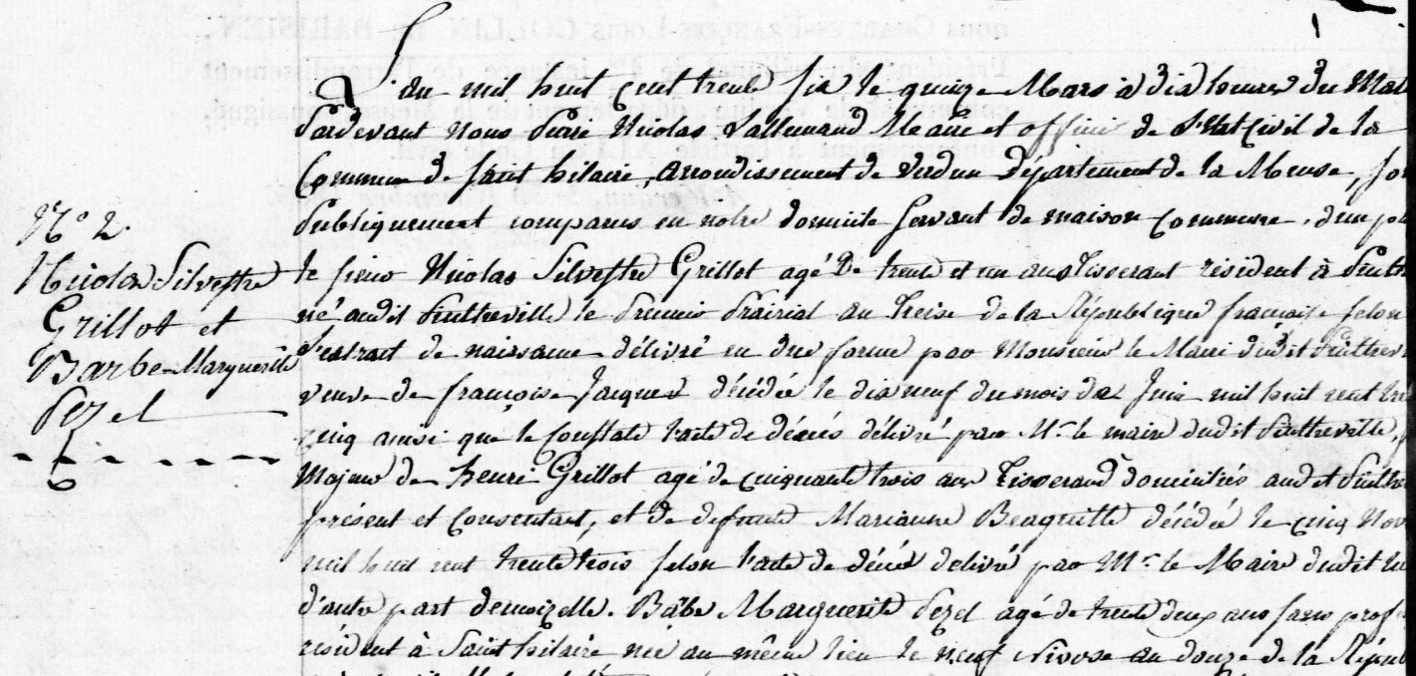
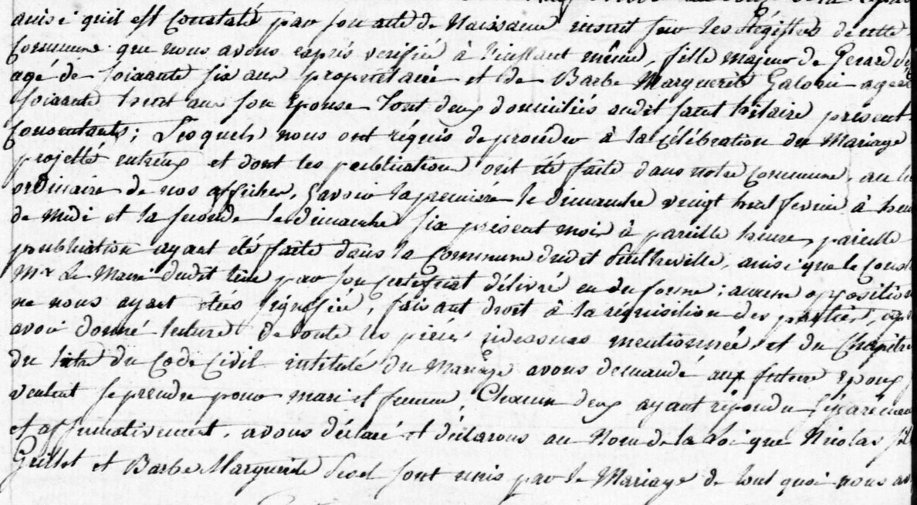
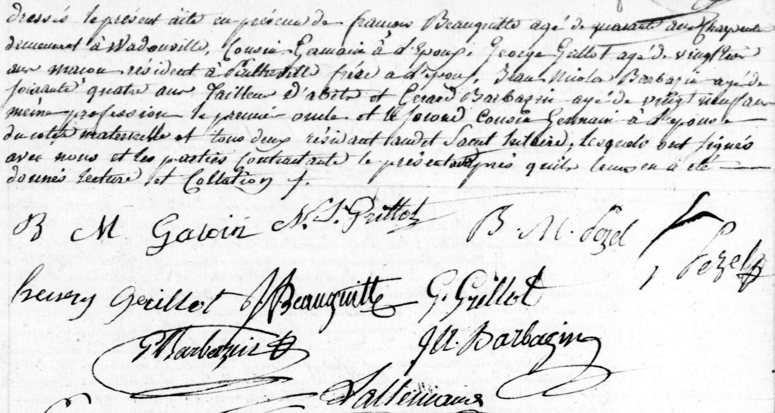
Second Marriage Record of Nicolas Silvestre Grillot, son of Henry Grillot (brother of Louis Grillot)
Source: archives.meuse.fr
Saint-Hilaire, 1833-1842 Births, Marriages, Deaths
Image 48/135

