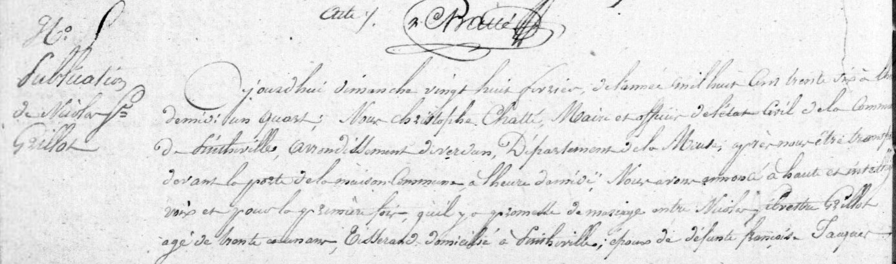
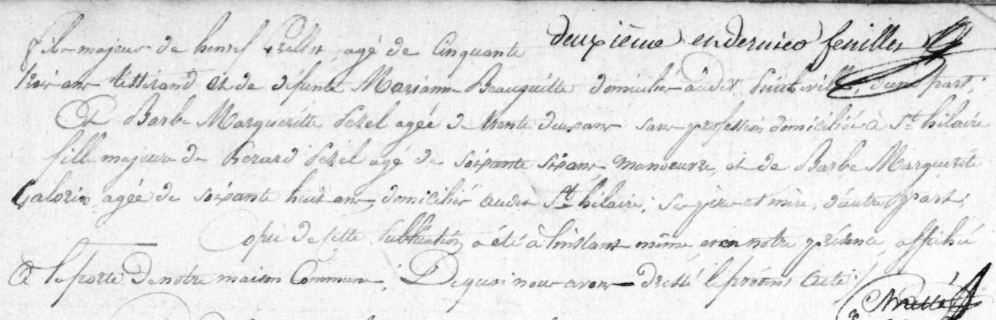
Publication of Marriage Banns for Nicolas Silvestre Grillot, son of Henry Grillot (bro of Louis Grillot)
Source: archives.meuse.fr
Etat Civil
Pintheville, 1833-1842, Births, Marriages, Deaths
Image 57/166

