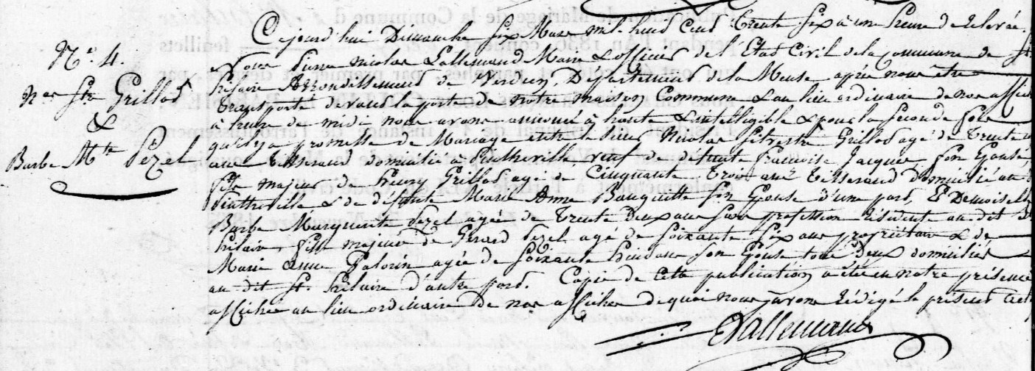
Publication of Marriage Banns (2nd marriage) for Nicolas Silvestre Grillot, son of Henry Grillot (brother of Louis Grillot)
Source: archives.meuse.fr
Saint-Hilaire, 1833-1843 Births, Marriages, Deaths
Image 45/135

