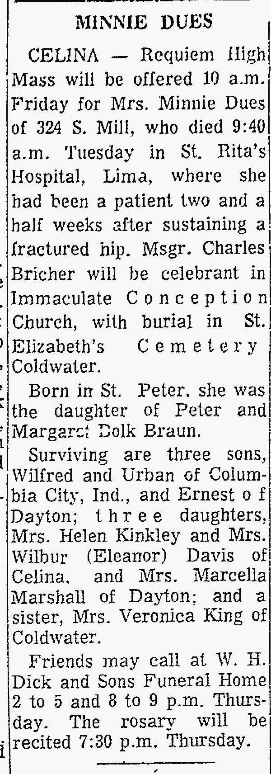
Philomena Braun Dues, half-sister of John M. Braun
The Lima News
26 Jun 1969

