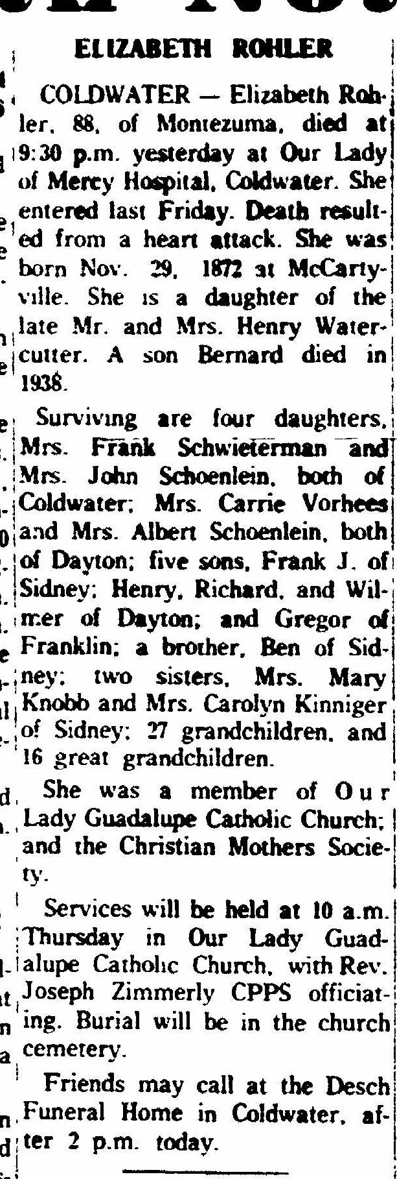
Obituary of Elizabeth Watercutter Rohler, sister of Mary Watercutter Knob
The Lima News
6 Jun 1961
Page 2, col 8

