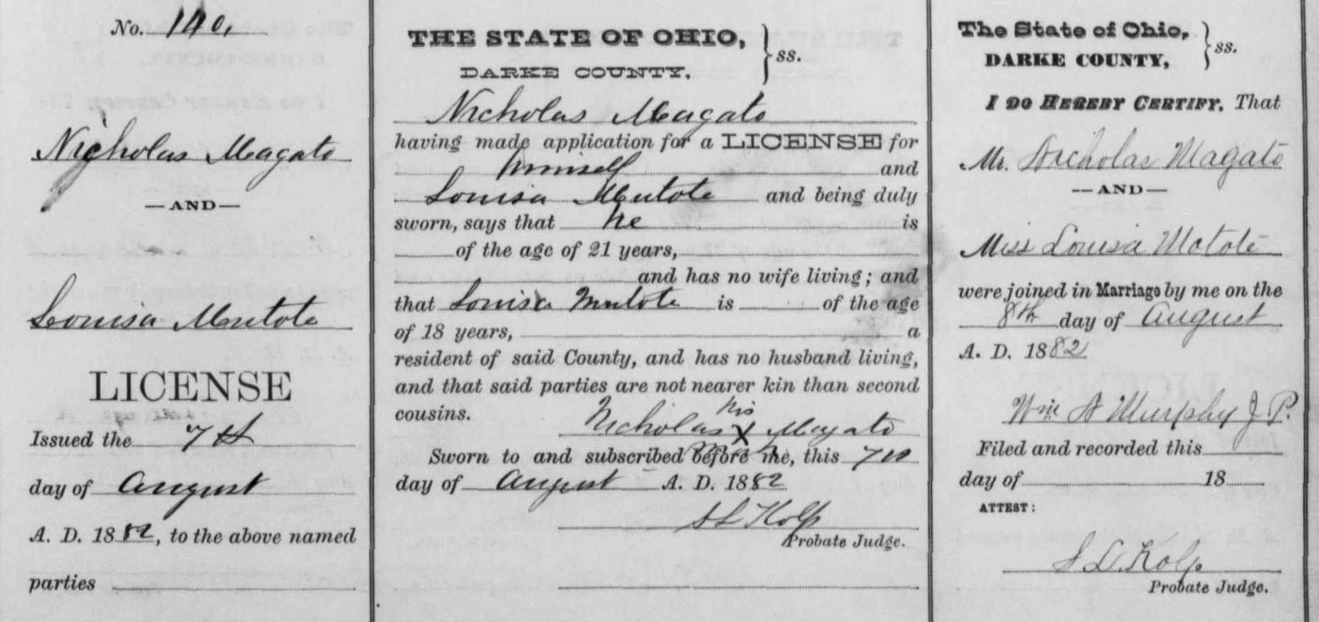

Nicholas Magato, "Ohio, County Marriages, 1789-1994"
name: | Nicholas Magato
titles and terms:
event type: | Marriage
event date: | 08 Aug 1882
event place: | Darke, Ohio, United States
event place (original):
age:
birth year (estimated):
birth date:
birthplace:
father's name:
father's titles and terms:
mother's name:
mother's titles and terms:
spouse's name: | Louisa Mutote
spouse's titles and terms:
spouse's age:
spouse's birth year (estimated):
spouse's birthplace:
spouse's father's name:
spouse's father's titles and terms:
spouse's mother's name:
spouse's mother's titles and terms:
reference id: | v f p 47 n 140
gs film number: | 1030773
digital folder number: | 004017445
image number: | 00387

Citing this Record
"Ohio, County Marriages, 1789-1994," index and images, FamilySearch (https://familysearch.org/pal:/MM9.1.1/X8KJ-GQP : accessed 07 Mar 2013), Nicholas Magato and Louisa Mutote, 1882.

