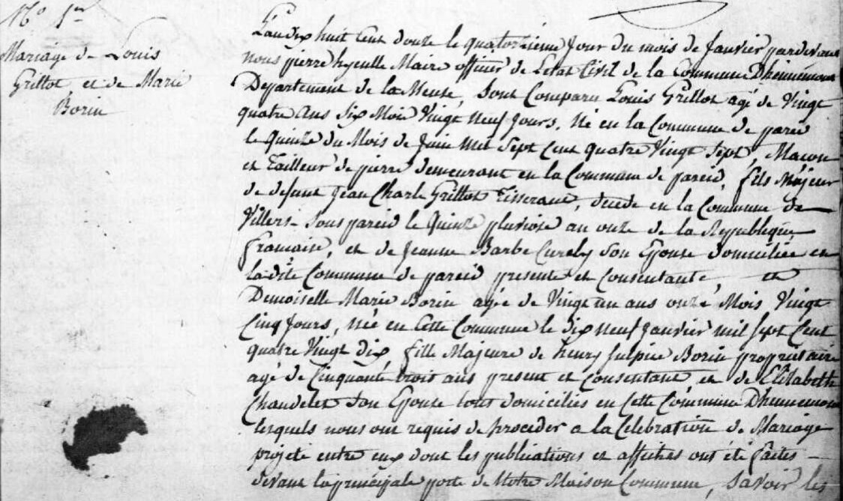
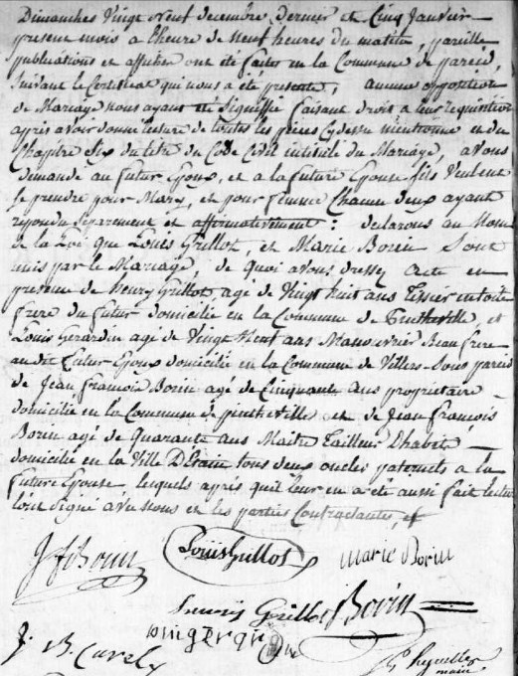
Marriage Record of Louis Grillot and Marie Borin
Source: http://archives.meuse.fr
Hennemont
1802-1812 Births Marriages Deaths
Images 126-127/132

