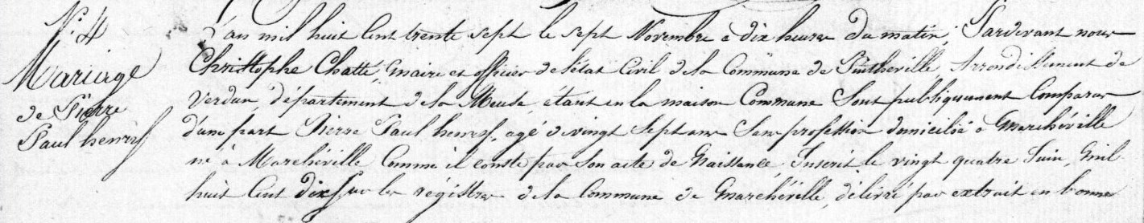
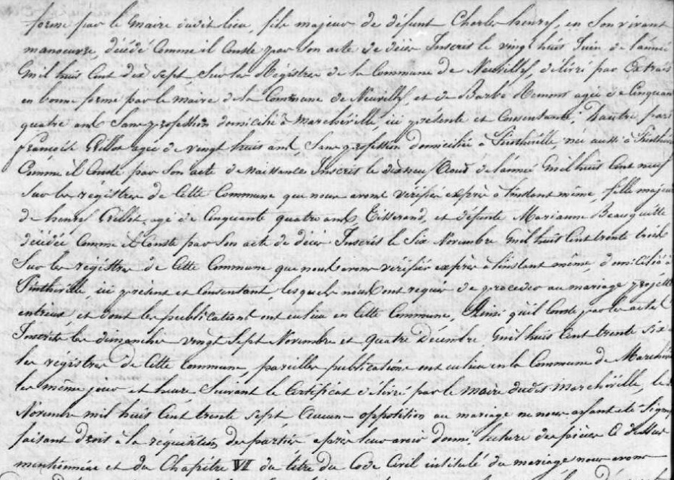

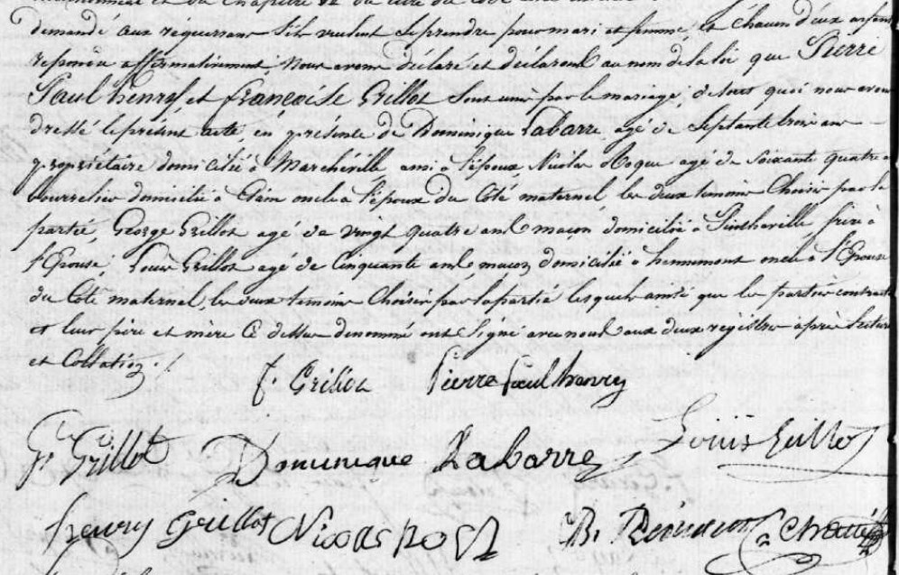
Marriage Record of Francoise Grillot, daughter of Henry Grillot (bro of Louis Grillot)
Source: archives.meuse.fr
Etat Civil
Pintheville, 1833-1842 Births, Marriages, Deaths
Image 80/166

