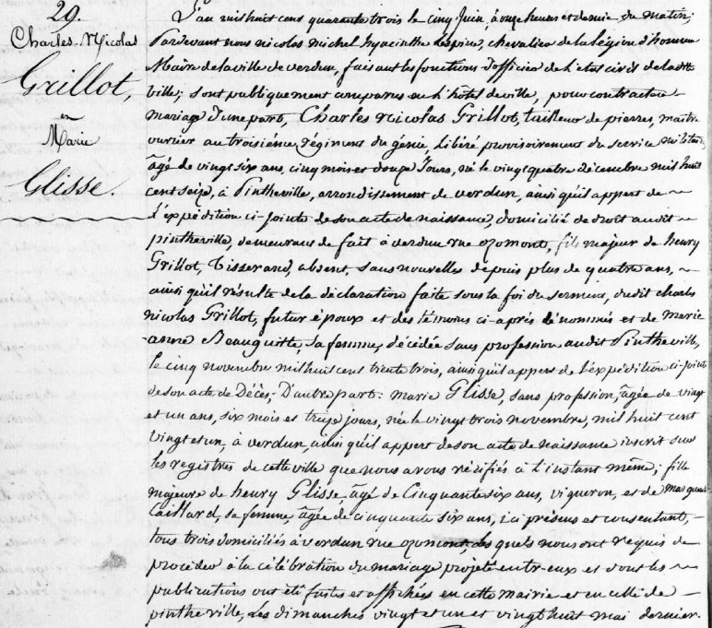
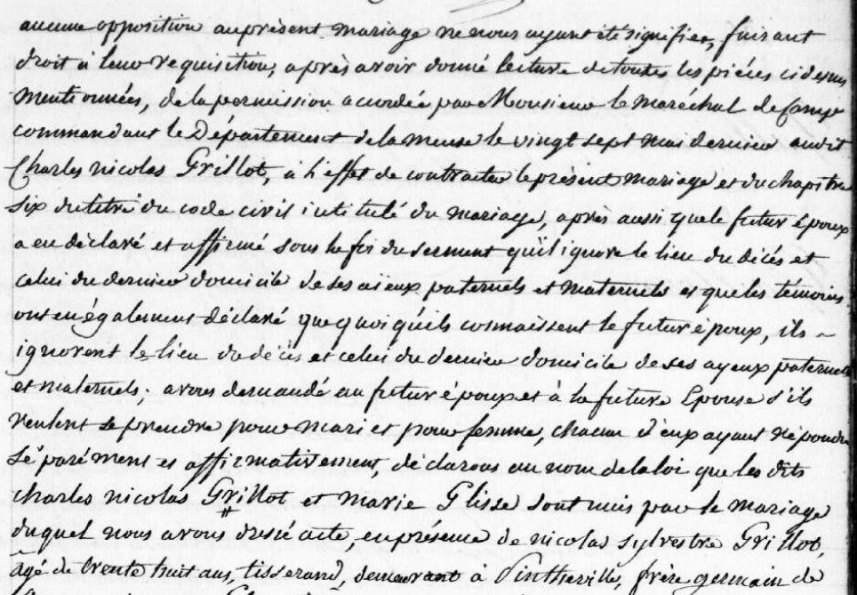
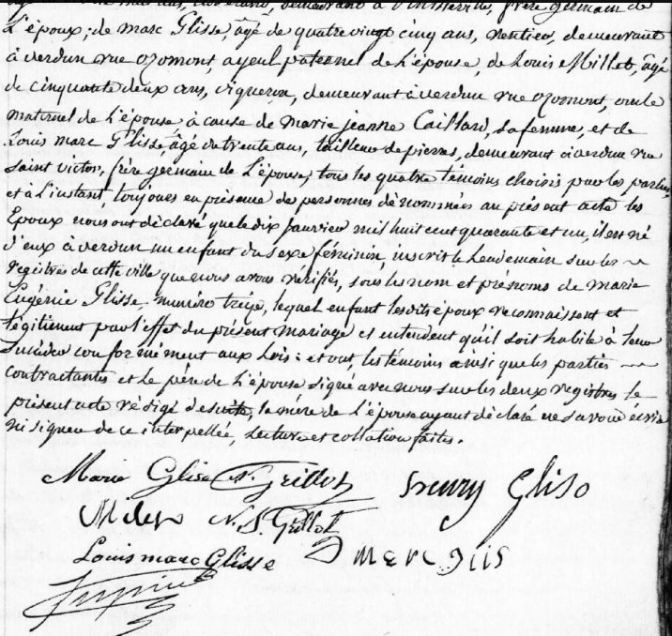
Marriage Record of Charles Nicolas Grillot, son of Henry Grillot (Brother of Louis Grillot)
Source: archives.meuse.fr
Verdun, 1843-1843, Births, Marriages, Deaths
Image 170/512

