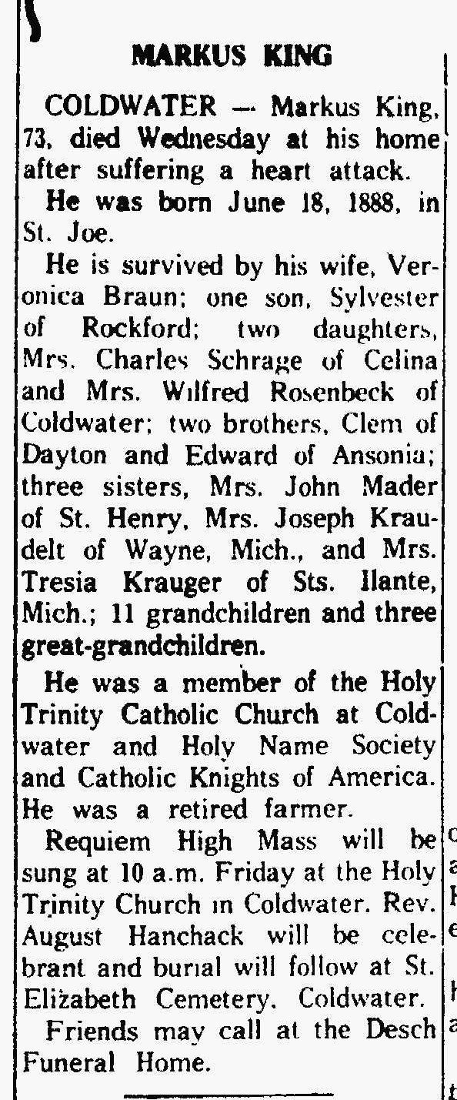
Markus King, husband of Veronica Braun King
The Lima News
14 Mar 1962

