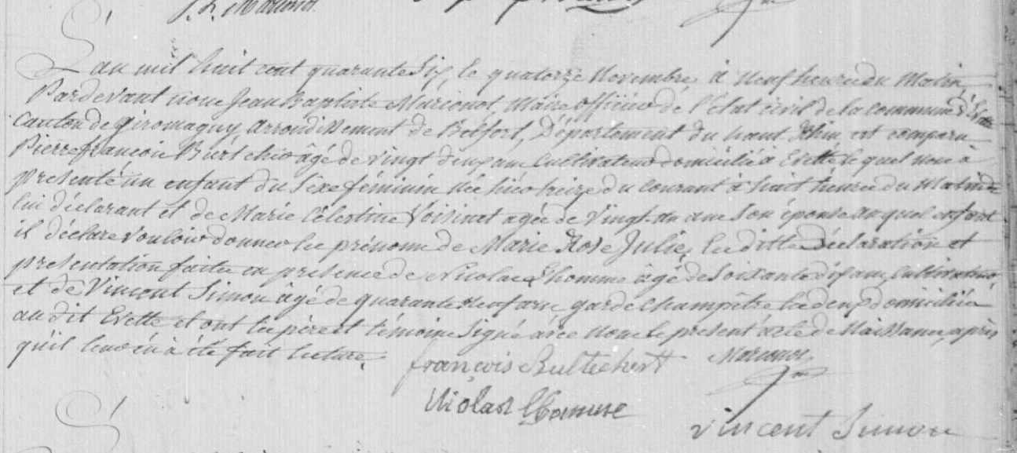
Marie Rose Julie Burtcher Civil Birth Record (1846)
Source: http://www.archives.cg90.fr/?id=etat_civil
Evette, Births, Deaths, Marriages 1803-1869
Cote 1 E 42, N.D.M. 1-3
Image 485/783

