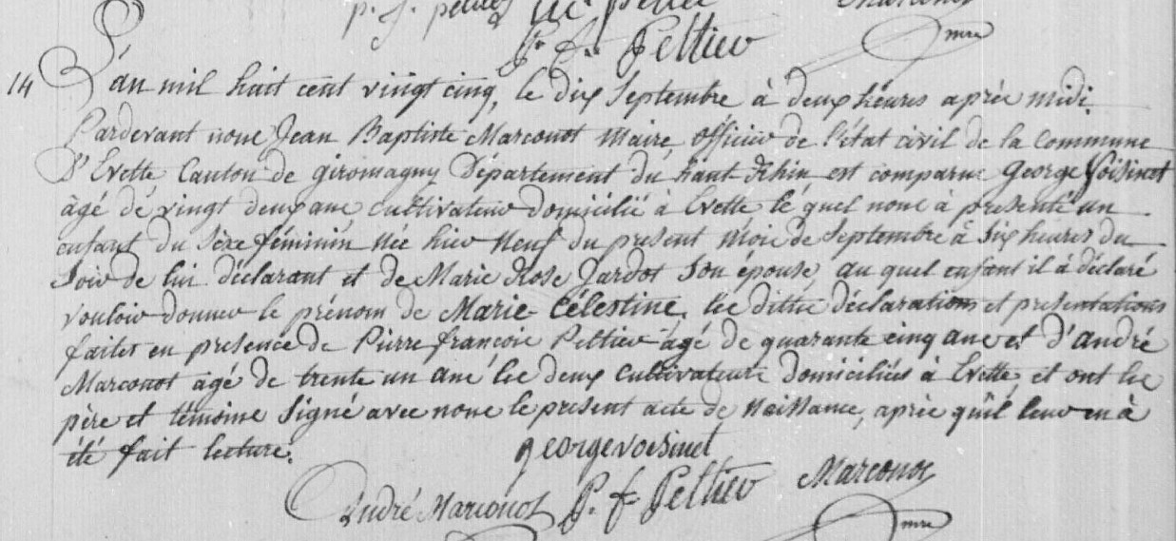
Marie Celestine Voisinet civil birth record
Source: http://www.archives.cg90.fr/?id=etat_civil
Evette, Births, Marriages, Deaths 1803-1869
Cote 1 E 42, N.D.M. 1-3
Image 198/783

