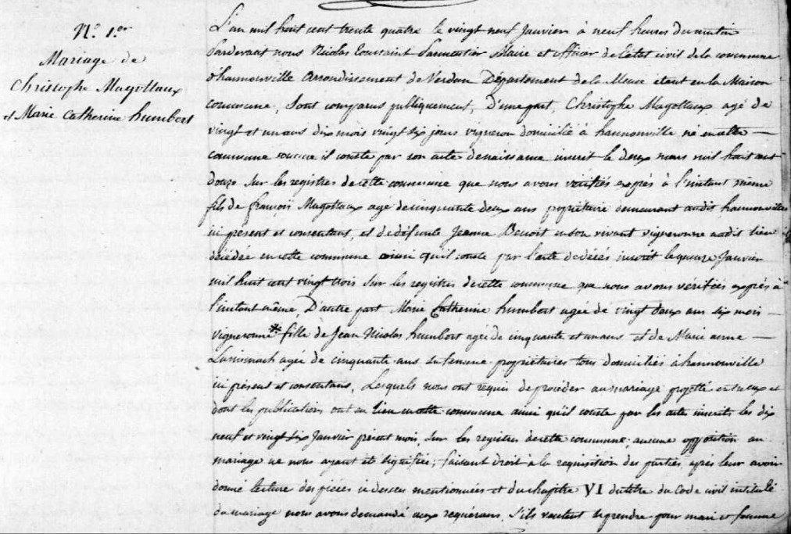
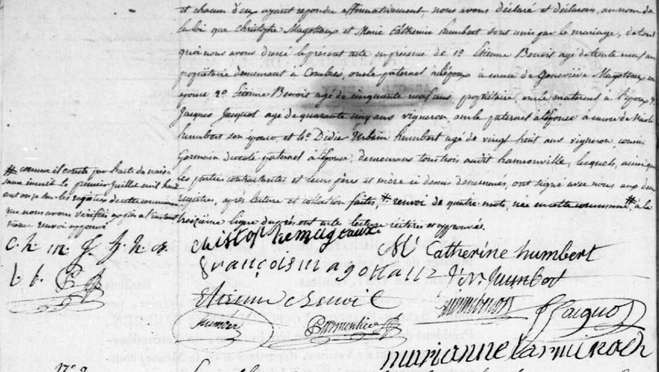
Magotaux-Humbert Marriage 29 Jan 1834
Source: http://archives.meuse.fr Etat Civil Hannonville-sous-les-Cotes
1833-1842 Births Marriages Deaths Images 98-99/447

