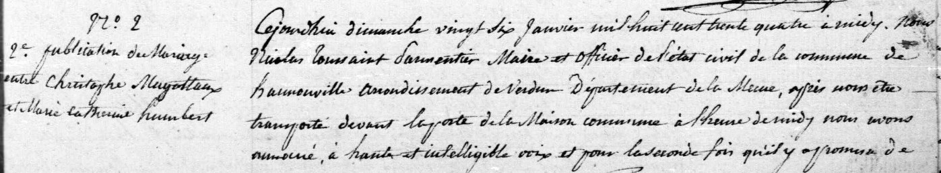
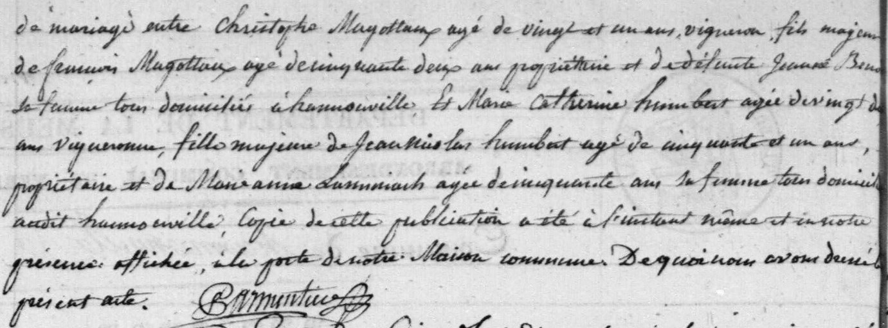
Magotaux-Humbert 2nd Marriage Banns
26 Jan 1834
Source: http://archives.meuse.fr
Etat Civil
Hannonville-sous-les-Cotes
1833-1842 Births Marriages Deaths
Images 93-94/447

