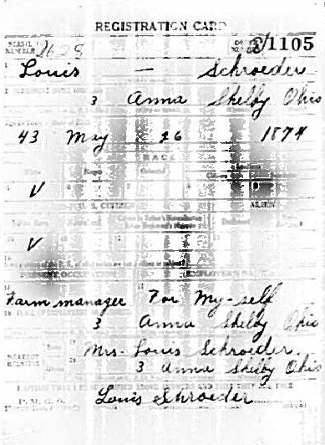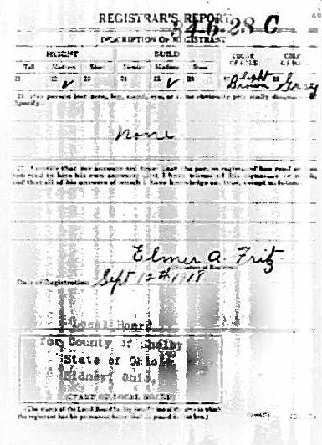
Louis Schroeder WWI Draft Registration Card
Brother of Joseph R. Schroeder
Son of Frank and Bernadina (Hut) Schroeder

