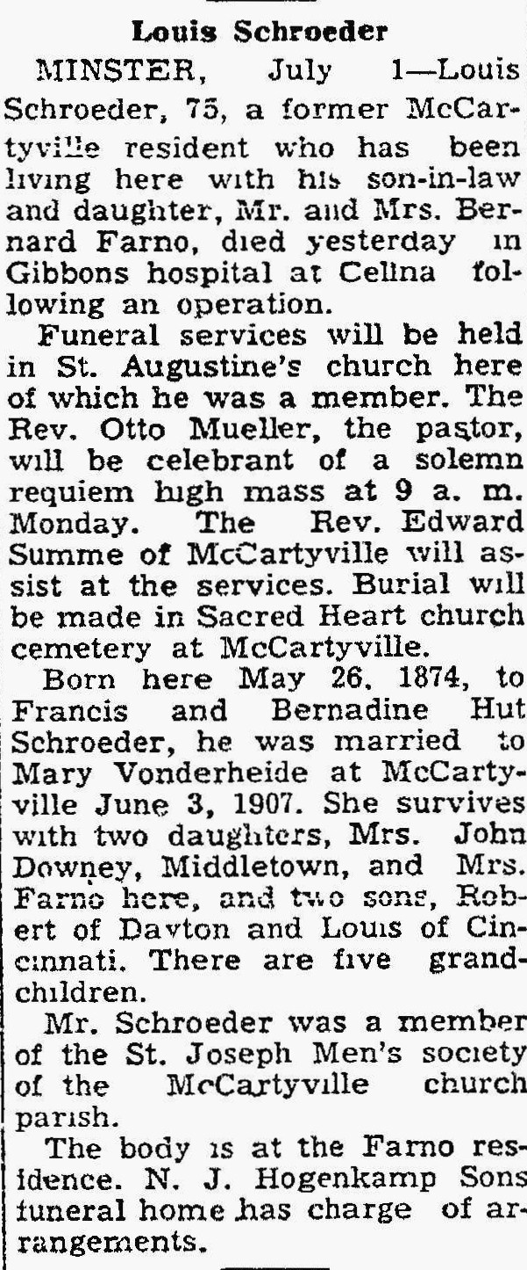
The Lima News
July 1, 1949

