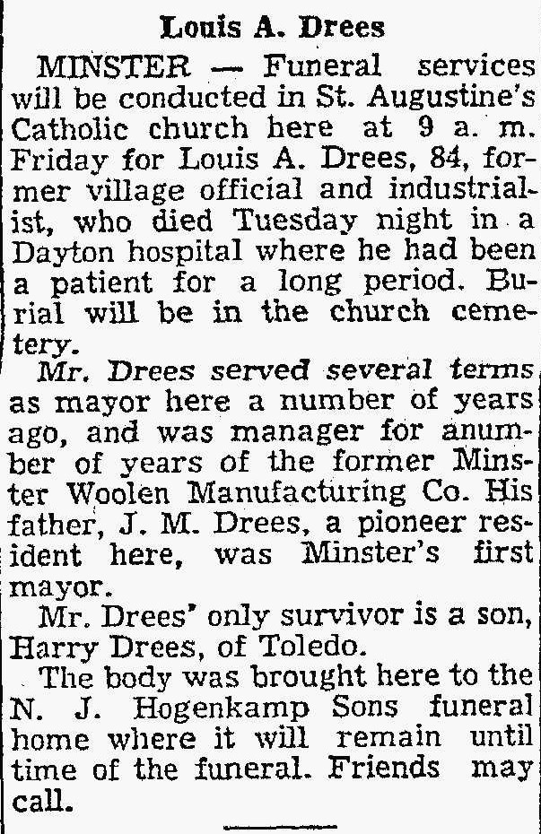
Brother of J.M. “Mike” Drees
The Lima News 20 Nov 1952

