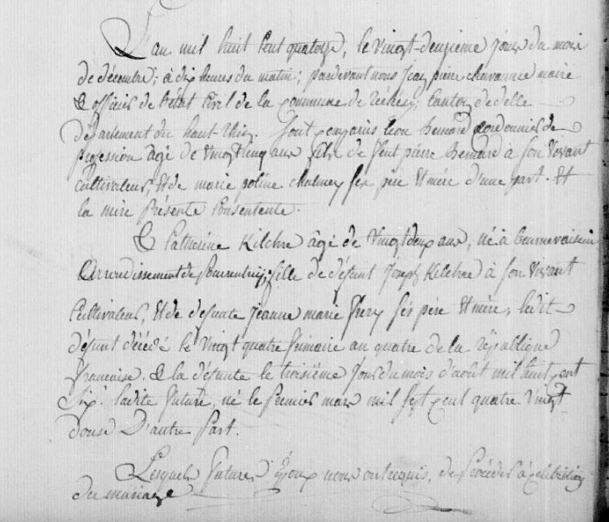
Leon Bernard and Catherine Kilker Marriage Record
Territoire de Belfort Archives, Rechesy
Etat Civil 1803-1829 1E 81 N.D.M. 1-2
Source: http://www.archives.cg90.fr/ark:/12997/a011341578574HL7fvX/1/1
Images 335-336/347

