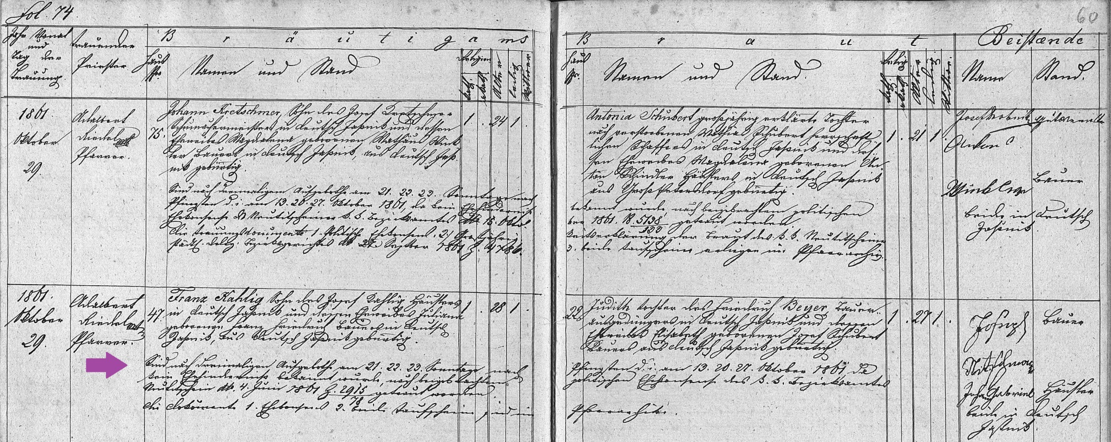
Church Marriage Record of Franz Kahlig and Judith Beyer 29 Oct 1861
FamilySearch.org
Czech Republic Church Books, 1552-1963
Catholic, Novy Jicin, Jesenik nad Odrou
Marriages 1836-1871 (vol 2038) Image 61/93

