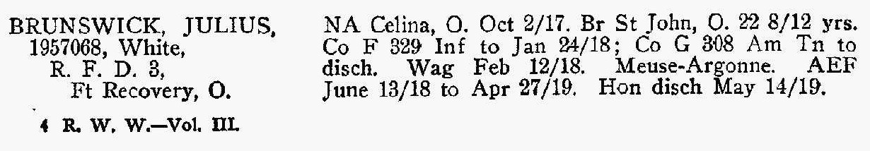
Birth Location: St John, Ohio, USA
Enlistment Date: 2 Oct 1917
Enlistment County: Celina
Enlistment State: Ohio
Enlistment Division: National Army

Comments:
Co F 329 Infantry to 24 Jan 1918; Co G 308 Ammunition Train to Discharge Wagoner 12 Feb 1918. Meuse-Argonne. American Expeditionary Forces 13 June 1918 to 27 Apr 1919. Honorable discharge 14 May 1919.

