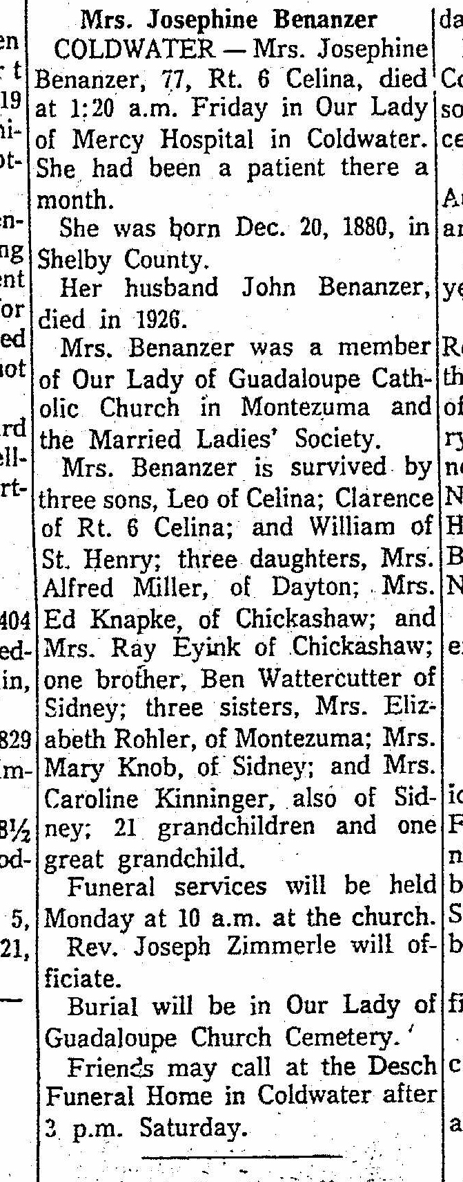
Obituary of Josephine Watercutter Benanzer, sister of Mary Watercutter Knob
The Lima News
15 Feb 1958 Page 4, Column 7

