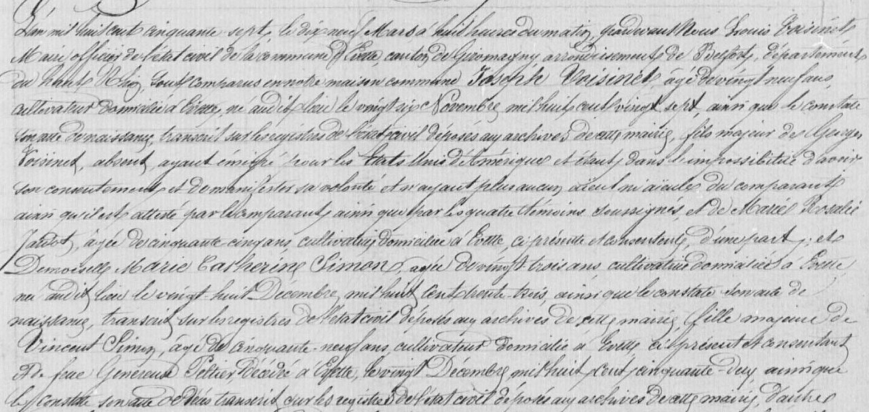
Joseph Voisinet Civil Marriage Record (1857), brother of Marie Celestine Voisinet Burtcher (PAGE 1)
Source: http://www.archives.cg90.fr/?id=etat_civil
Evette, Births, Deaths, Marriages 1803-1869
Cote 1 E 42, N.D.M. 1-3
Image 618/783

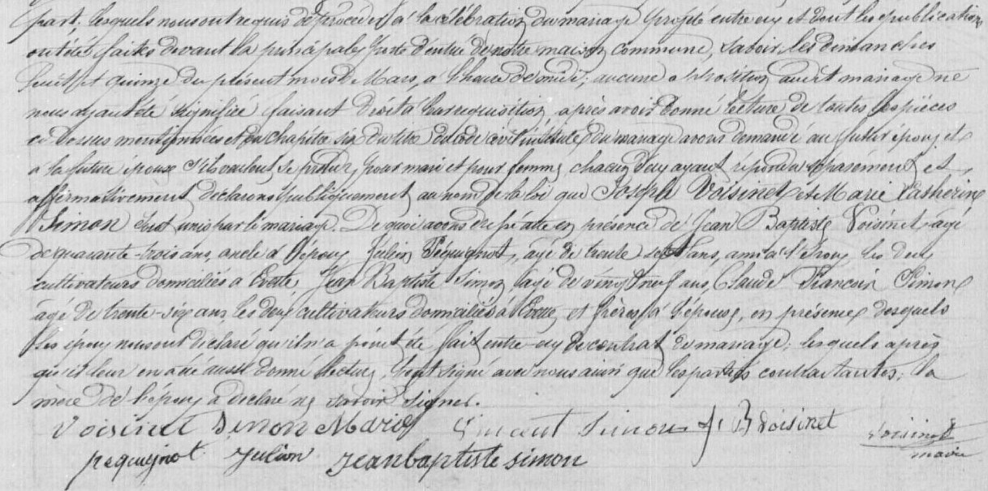
PAGE 2

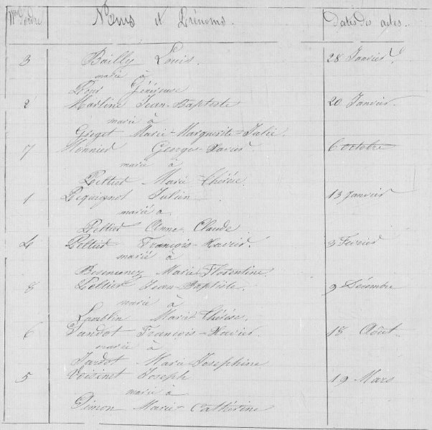
Civil Marriage Record Joseph Voisinet and Marie Catherine Simon (1857)
Image 620/783

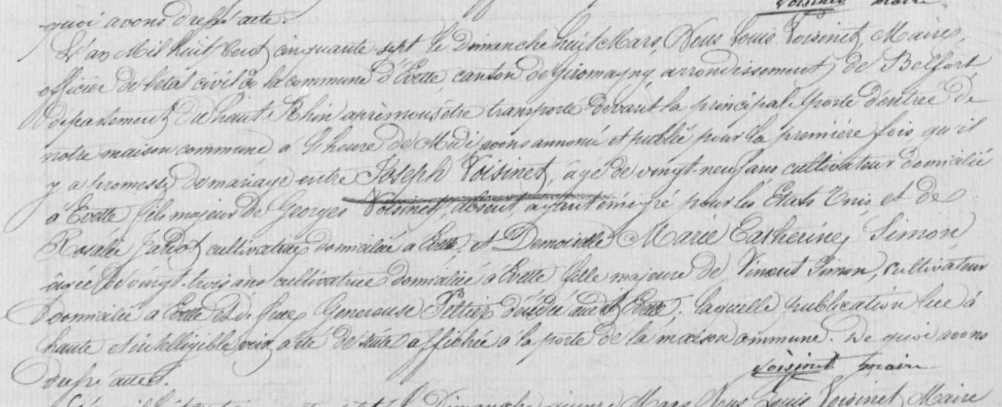
Publication of Marriage for Joseph Voisinet and Marie Catherine Simon (1857)
Image 621/783

