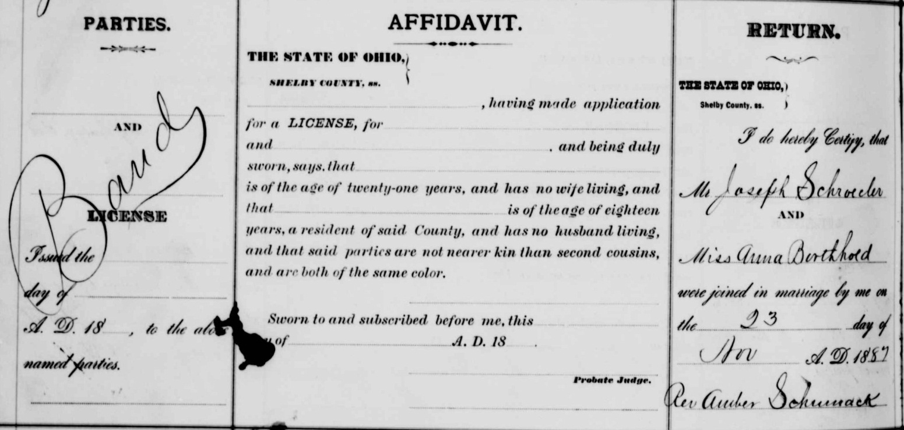
name: | Joseph Schroeder
titles & terms:
event: | Marriage
event date: | 23 Nov 1887
event place (standardized): | Shelby, Ohio, United States
event place (other):
age:
estimated birth year:
birth date:
birthplace:
father:
father's titles & terms:
mother:
mother's titles & terms:
spouse: | Anna Borthhold
spouse's titles & terms:
spouse's age:
spouse's estimated birth year:
spouse's birthplace:
spouse's father:
spouse's father's titles & terms:
spouse's mother:
spouse's mother's titles & terms:
reference number: | 346
film number: | 562861
digital folder number: | 004016864
image number: | 00209

Citing this Record
"Ohio, County Marriages, 1789-1994," index and images, FamilySearch (https://familysearch.org/pal:/MM9.1.1/X8Z9-SNB : accessed 31 Jan 2013), Joseph Schroeder and Anna Borthhold, 1887; citing reference 346, FHL microfilm 562861.

