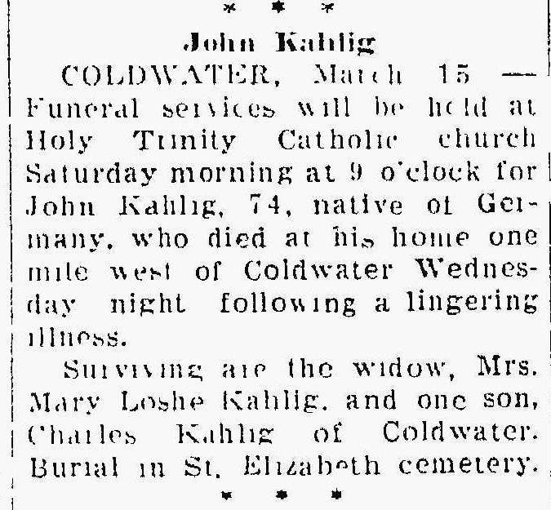
Obituary for Joseph Kahlig, brother of Louisa Kahlig Braun
The Lima News
15 Mar 1940, Page 4

