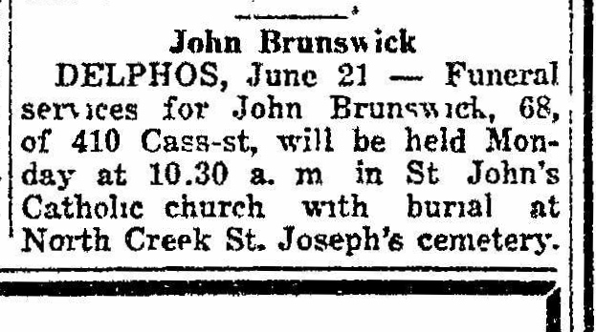
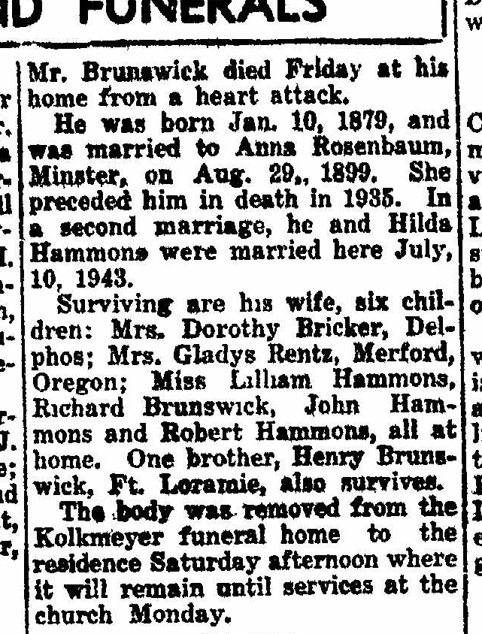

Obituary of John Brunswick, brother of Joseph A. Brunswick
The Lima News
22 June 1947 page 2, column 5-6

