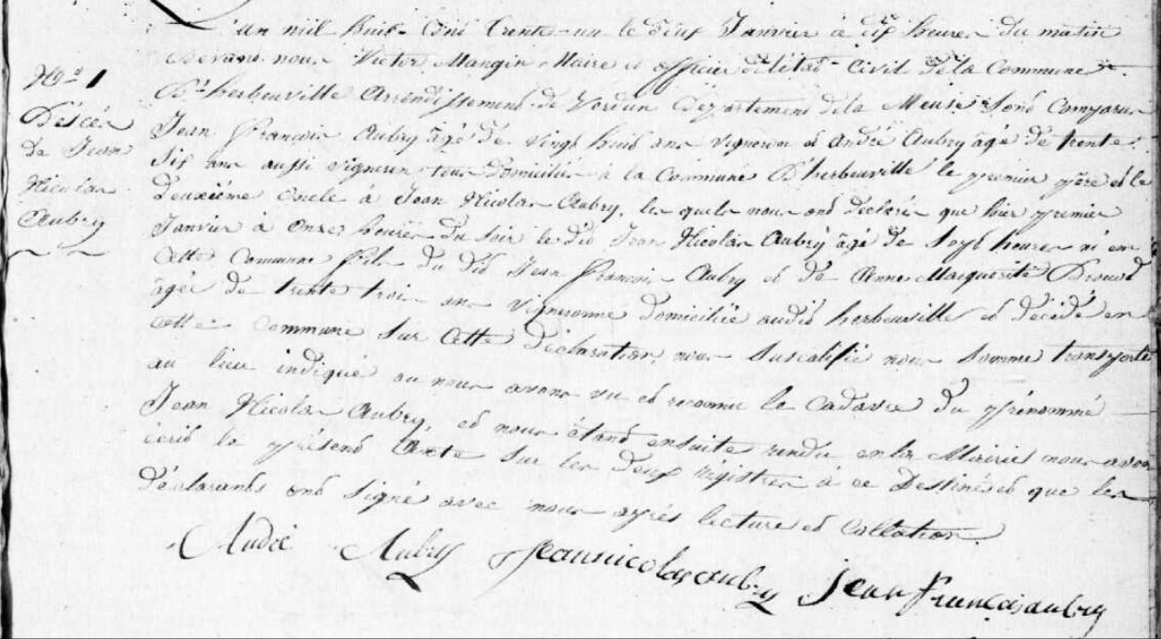
Jean Nicolas Aubry Death Record, brother of Marie Anne Aubry Grilliot
Source: archives.meuse.fr
Etat Civil
Herbeuville
1823-1832, Births, Marriages, Deaths
Image 301/353

