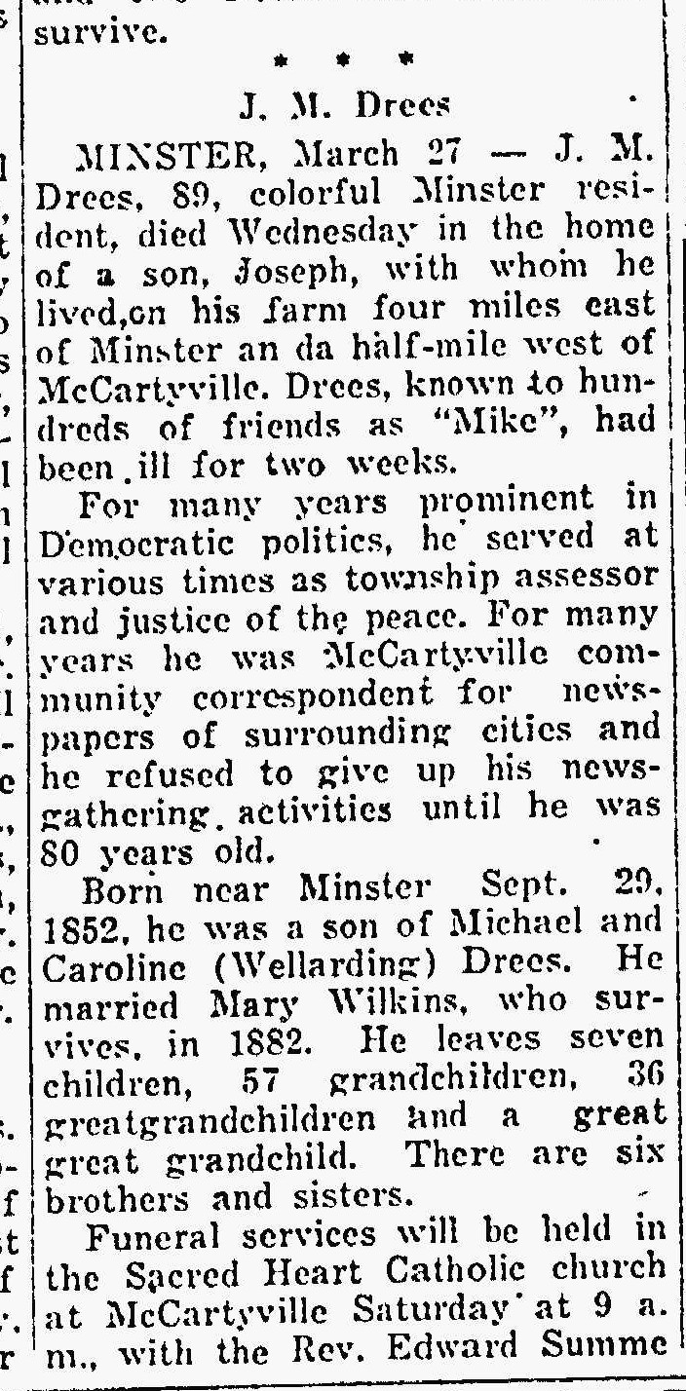

*The Lima News*

27 Mar 1941