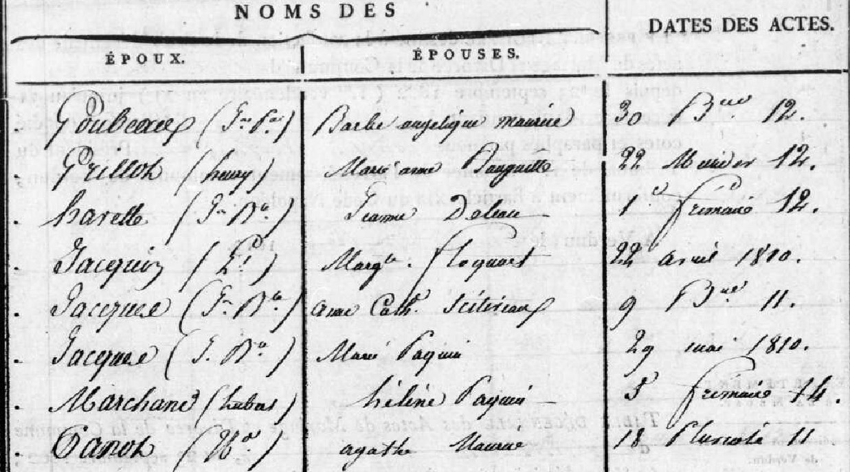

Image 5/91

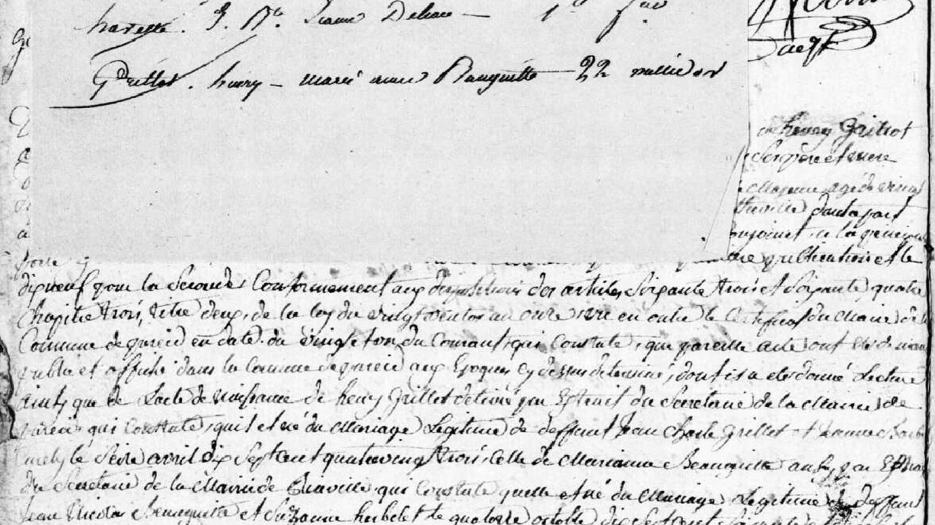

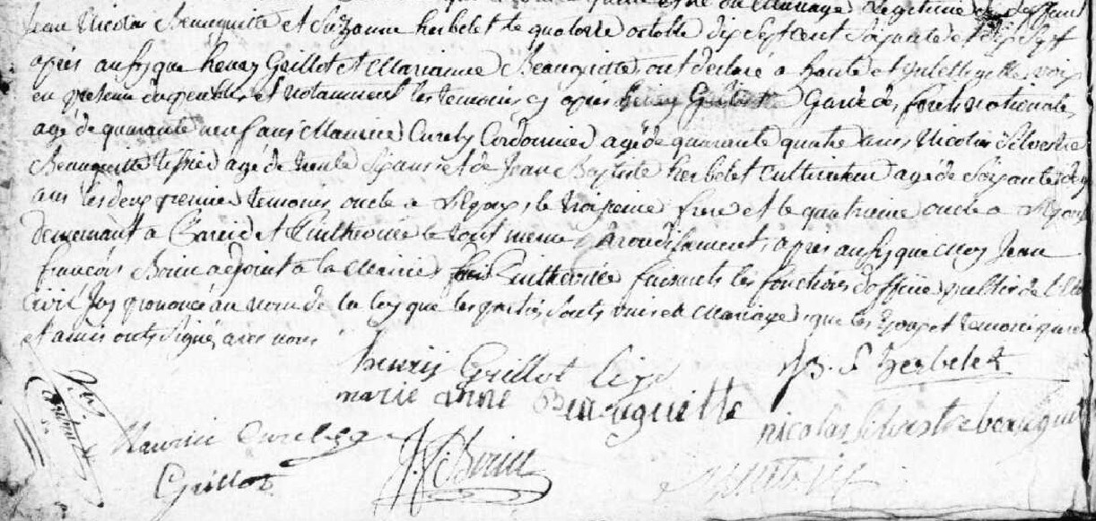

Marriage Record of Henry Grillot (bro. of Louis Grillot) and Marie Anne Beauguitte
http://archives.meuse.fr 2 E 414 (2)
Pintheville Births, Marriages, Deaths 1802-1812
Image 18/91

