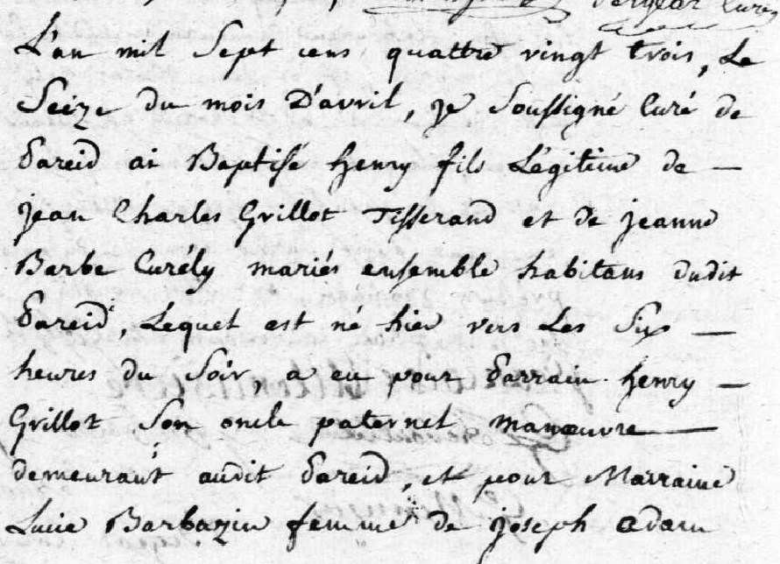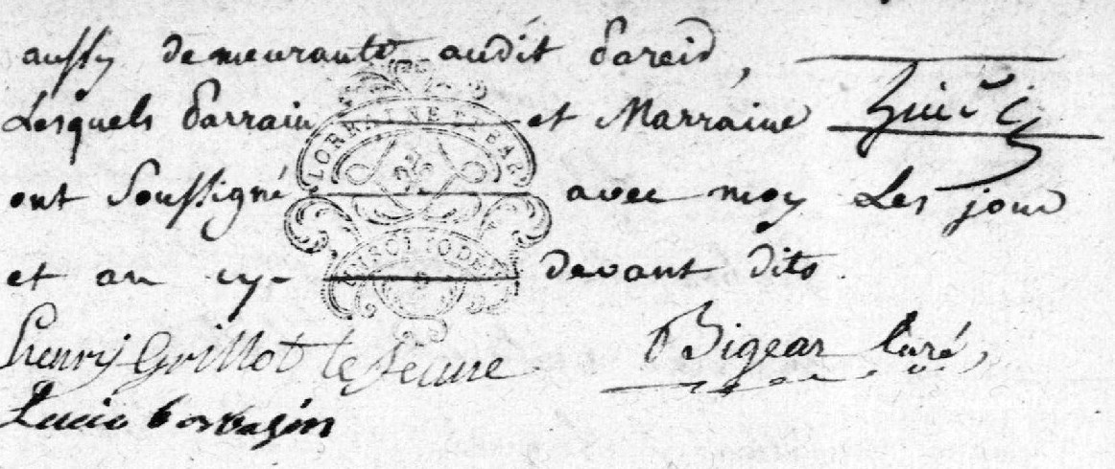
Henry Grillot Birth Record (brother of Louis Grillot)
http://archives.meuse.fr Etat Civil 1765-1791
Pareid Births, Marriages, Deaths 2 E 407 (1)
Image 157/285

