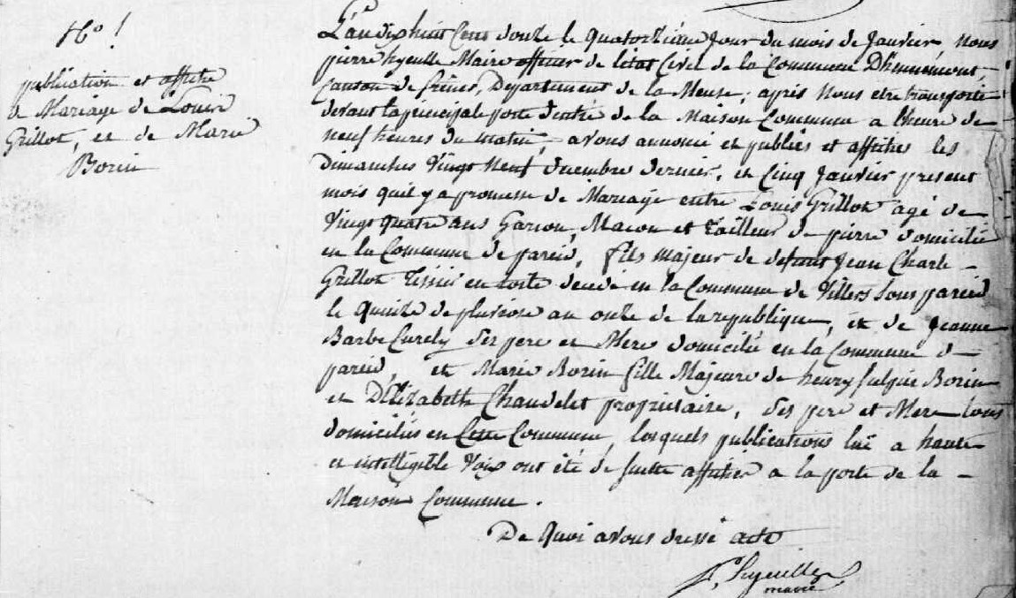
Marriage Banns of Louis Grillot and Marie Borin
Source: http://archives.meuse.fr/
Etat Civil, Hennemont 2 E 250 (4)
Births, Marriages, Deaths 1802-1812
Image 124

