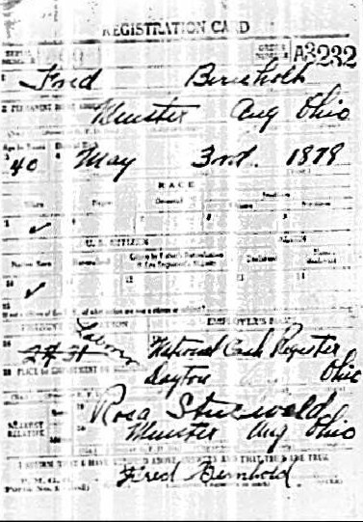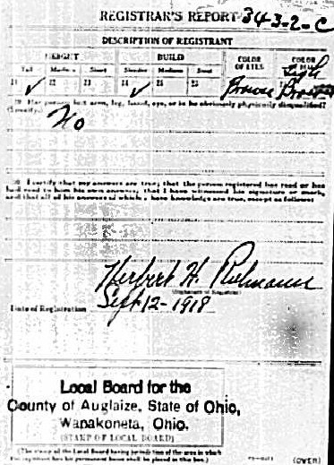
Friederick Bernhold, WWI Draft Card
Brother of Anna Bernhold Schroeder

