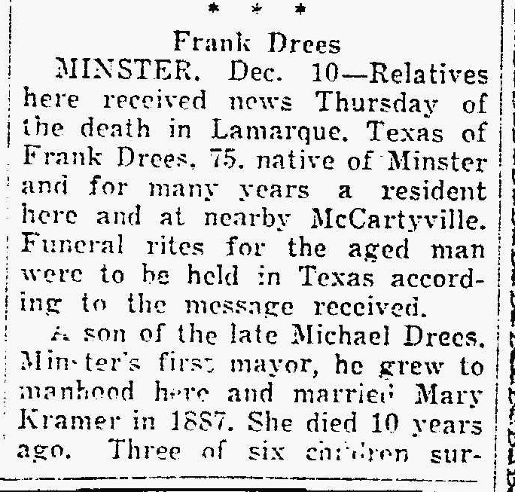
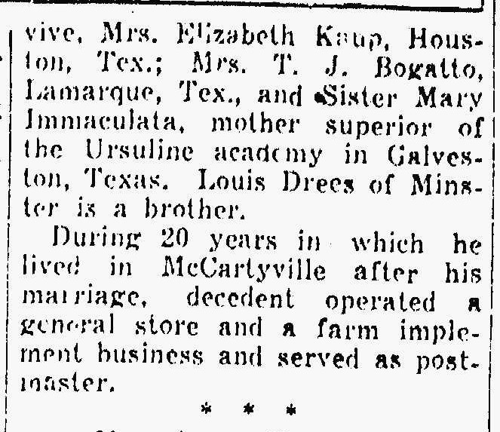
Brother of J.M. “Mike” Drees
The Lima News 10 Dec 1943 Page 4

