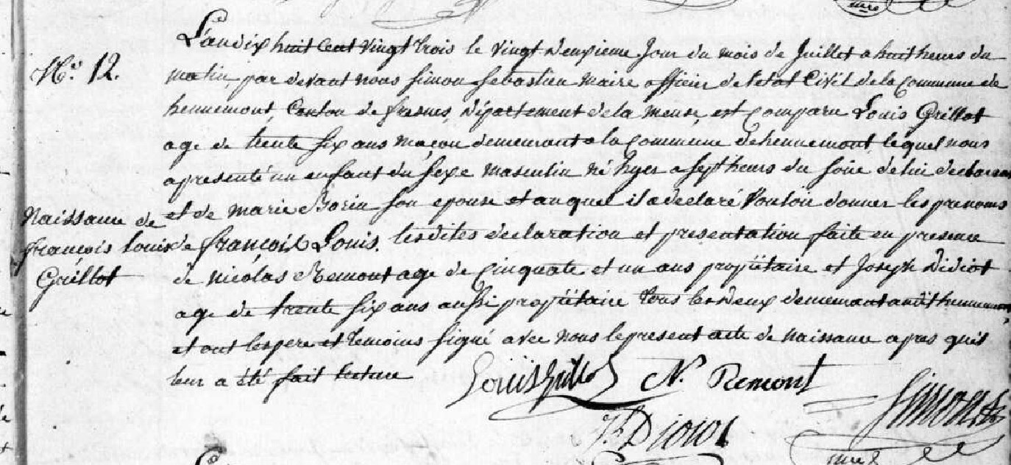
Francois Louis Grillot, son of Louis Grillot and Marie Borin Birth Record
Source: http://archives.meuse.fr
Etat Civil Hennemont 2E 250 (6) 1823-1832
Births, Marriages, and Deaths
Image 13/213

