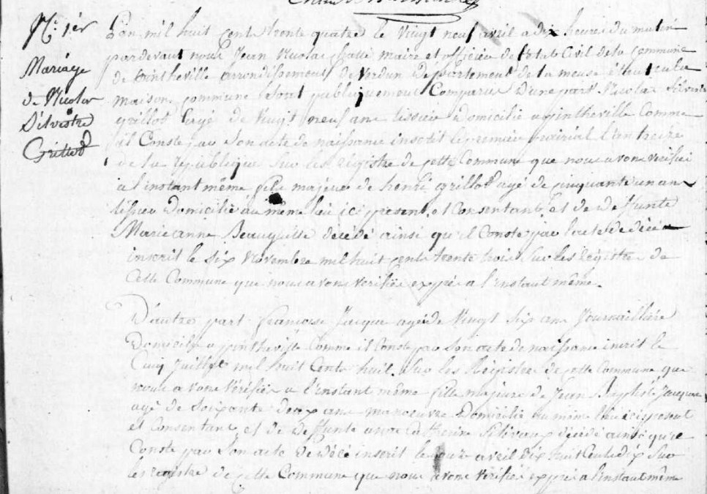
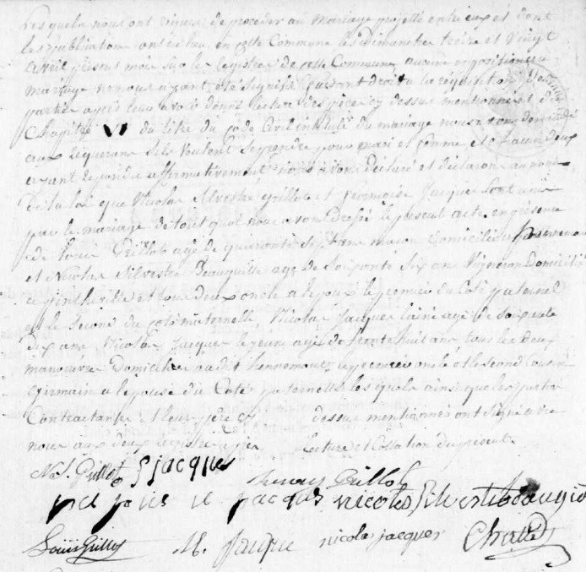
First Marriage of Nicolas Silvestre Grillot, son of Henry Grillot (bro of Louis Grillot)
Source: archives.meuse.fr Etat Civil Pintheville, 1833-1842 Births, Marriages, Deaths Image 28/166

