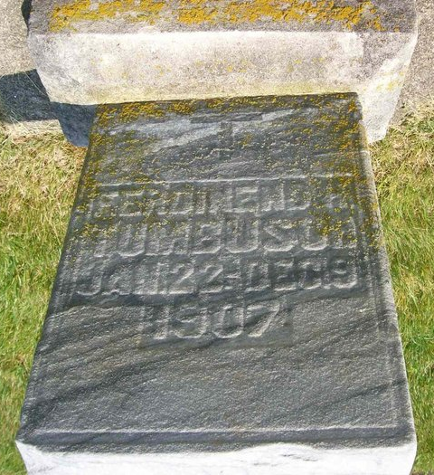

Ferdinand H. Tumbusch b. 22 Jun 1907 d. 9 Dec 1907
St. Henry’s Church Cemetery, St. Henry, Ohio
Brother of Frank Tumbush

"Ohio, Deaths and Burials, 1854-1997," Ferdie Tumbusch, 1907
Name: | Ferdie Tumbusch
Gender: | Male
Burial Date:
Burial Place:
Death Date: | 09 Dec 1907
Death Place: | Saint Henry, Mercer, Ohio
Age: | 0
Birth Date: | 1907
Birthplace:
Occupation:
Race:
Marital Status:
Spouse's Name:
Father's Name:
Father's Birthplace:
Mother's Name:
Mother's Birthplace:
Indexing Project (Batch) Number: | I10148-4
System Origin: | Ohio-EASy
Source Film Number: | 914954
Reference Number:

