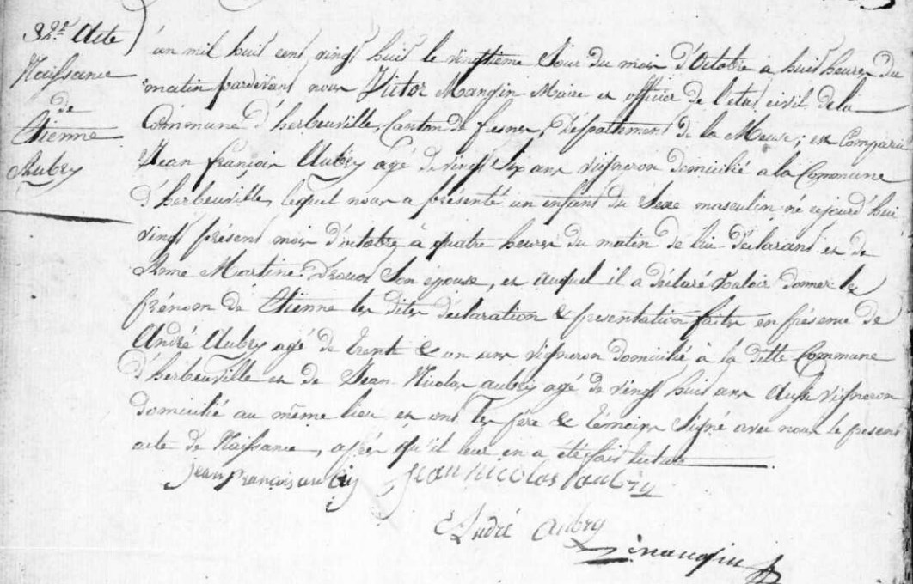
Etienne Aubry Birth Record
Source: archives.muese.fr
Etat Civil
Herbeuville
1823-1832, Births, Marriages, Deaths Image 154/353

