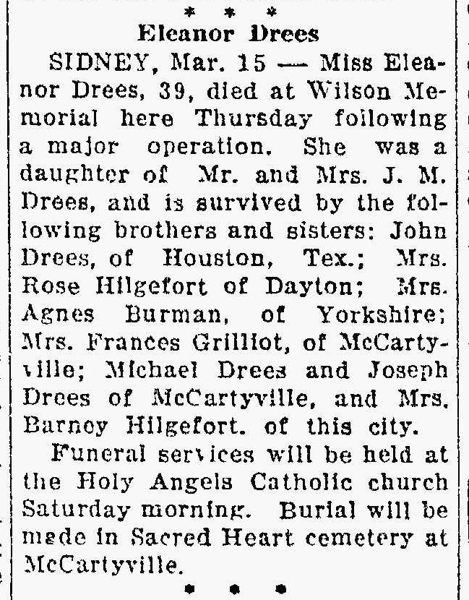
Sister of Frances Drees
The Lima News 15 Mar 1935 Page 2

