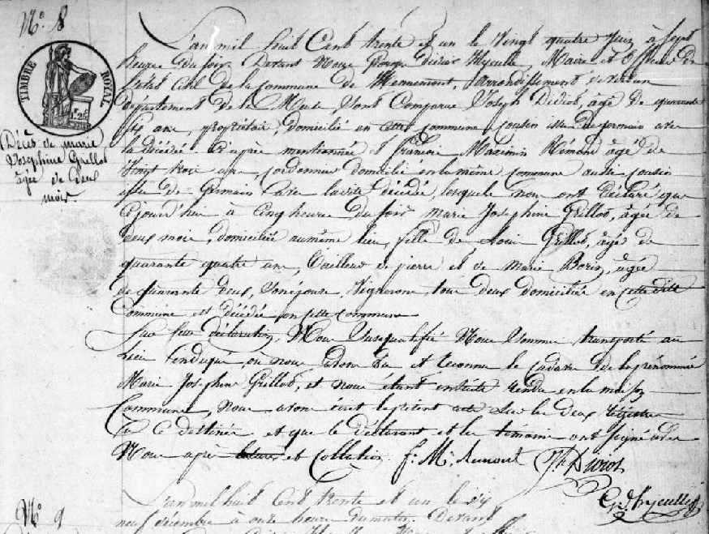
Death Record of Marie Josephine Grillot, daughter of Louis Grillot and Marie Borin
Source: http://archives.meuse.fr Etat Civil Hennemont 2 E 250 (6) 1823-1832
Births, Marriages, Deaths Image 195/213

