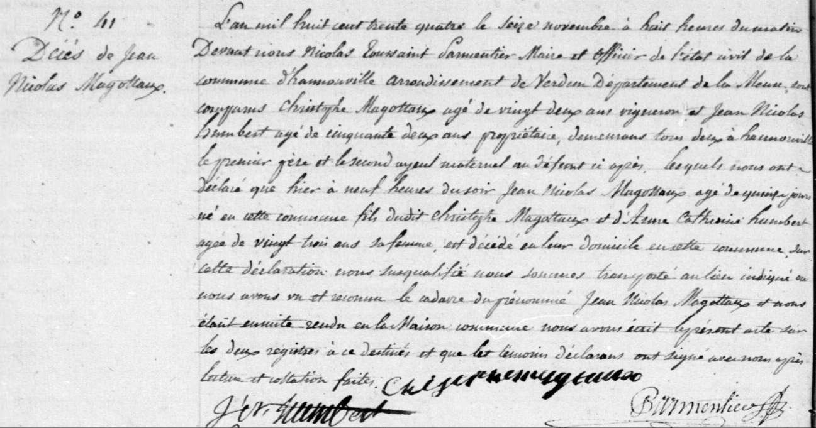
Death Record of Jean Nicolas Magottaux, brother of Jules Magotaux
Source: http://archives.meuse.fr
Etat Civil
Hannonville-sous-les-Cotes
1833-1842 Births Marriages Deaths
Image 118/447

