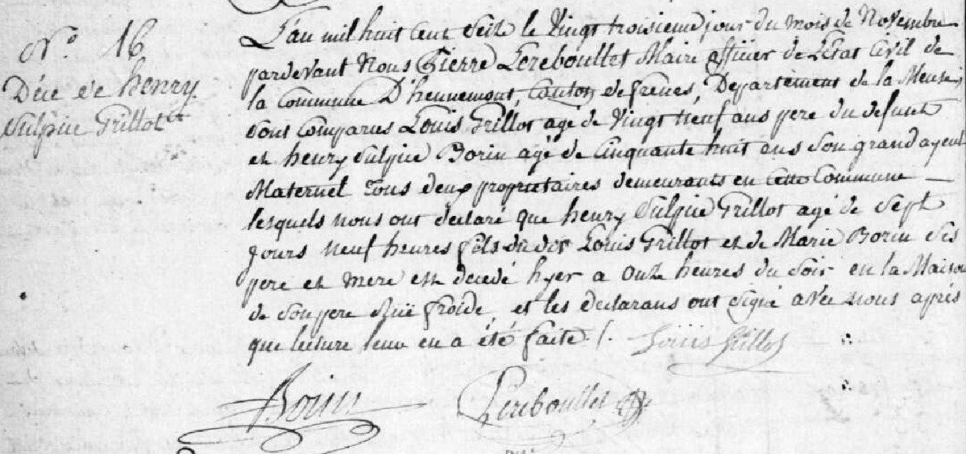
Death Record of Henry Sulpice Grillot (1816-1816), son of Louis Grillot and Marie Borin
Source: http://archives.meuse.fr
Hennemont, 2 E 250 (5)
Births, Marriages, Deaths 1813-1822
Image 52/115

