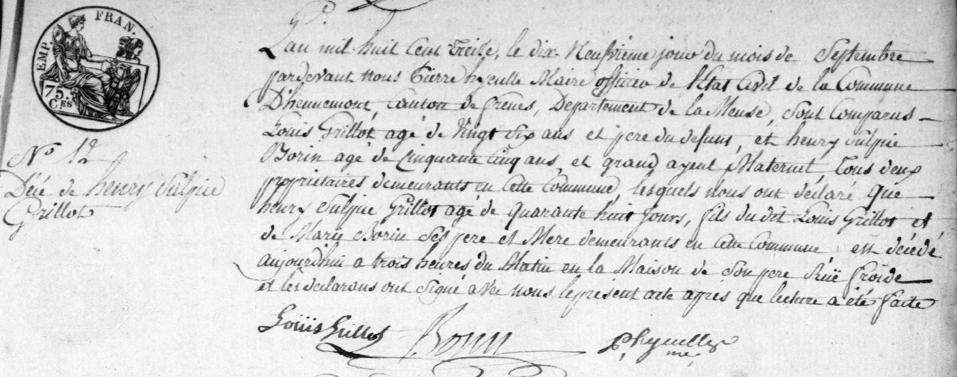
Death Record of Henry Sulpice Grillot I, son of Louis Grillot and Marie Born
Source: http://archives.meuse.fr
Hennemont, 2 E 250 (5)
Births, Marriages and Deaths 1813-1822
Image 19/115

