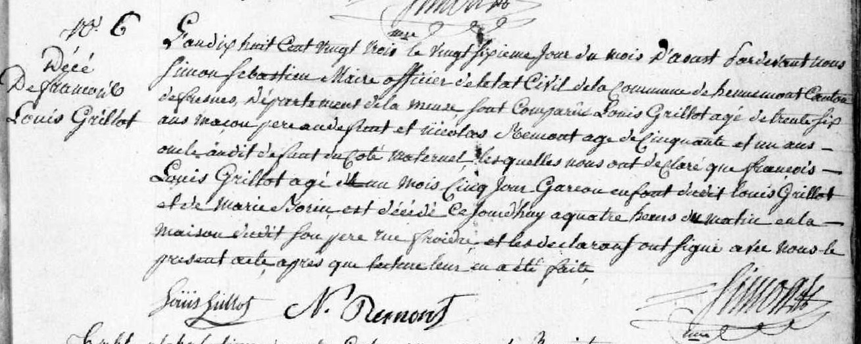
Death Record of Francois Louis Grillot, son of Louis Grillot and Marie Borin
Source: http://archives.meuse.fr
Etat Civil Hennemont 2 E 250 (6)
1823-1832 Births, Marriages, Deaths
Image 20/213

