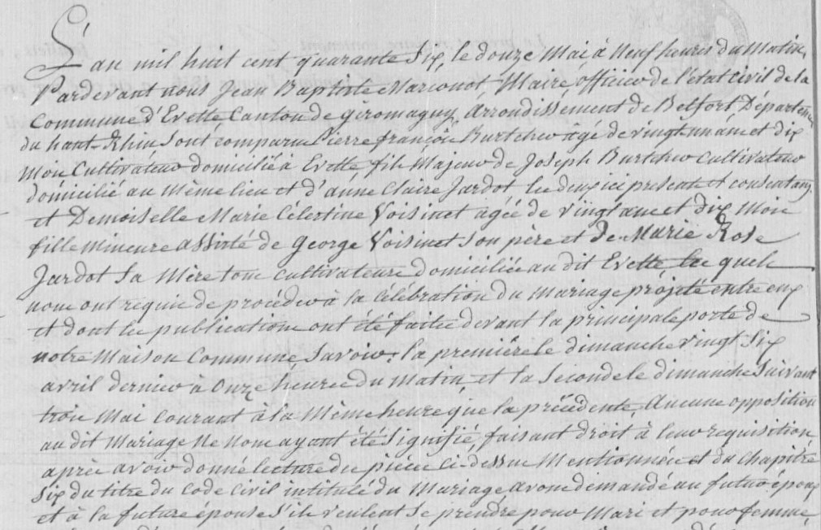
Civil Marriage Record of Pierre Francois Burtcher and Marie Celestine Voisinet (1846) Page 1
Source: http://www.archives.cg90.fr/?id=etat_civil
Evette, Births, Deaths, Marriages 1803-1869
Cote 1 E 42, N.D.M. 1-3
Image 492/783
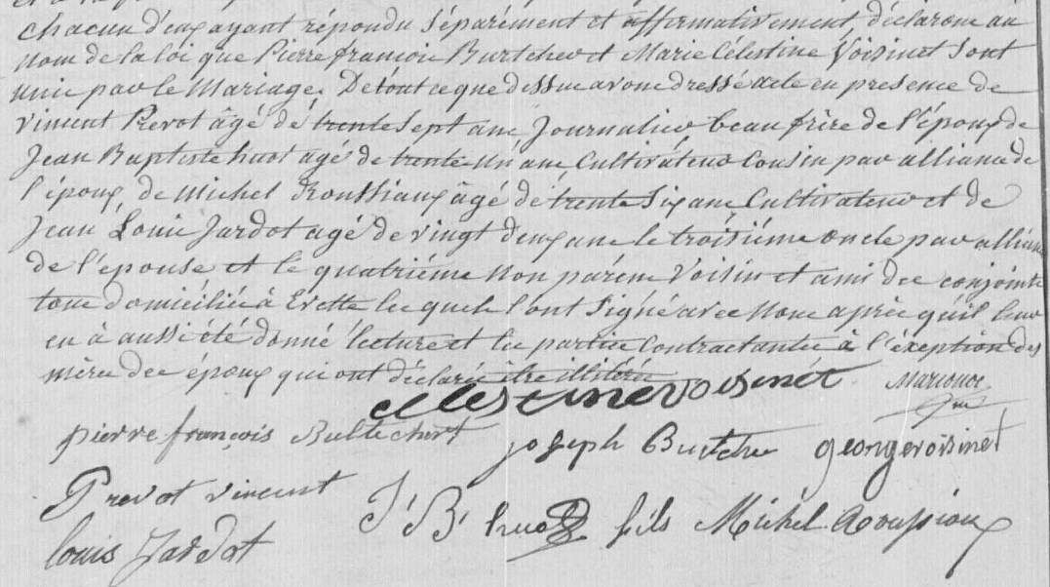
Page 2

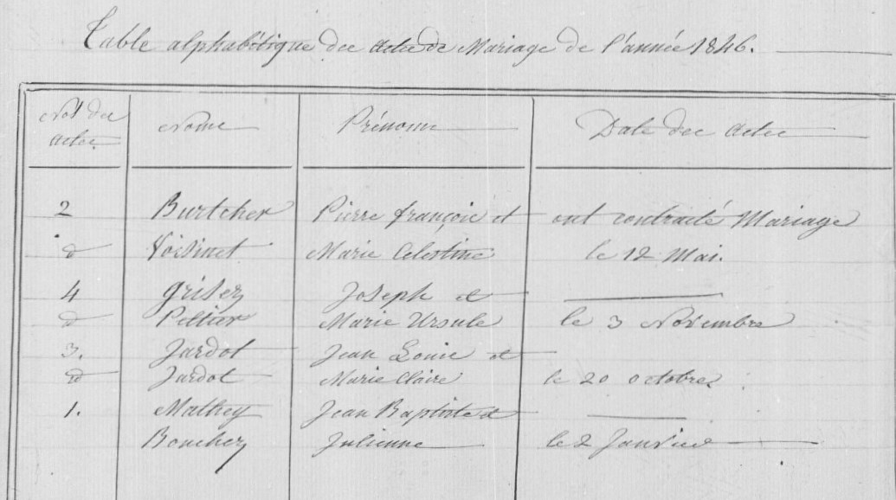
Table with Burtcher-Voisinet Wedding
Image 494/783

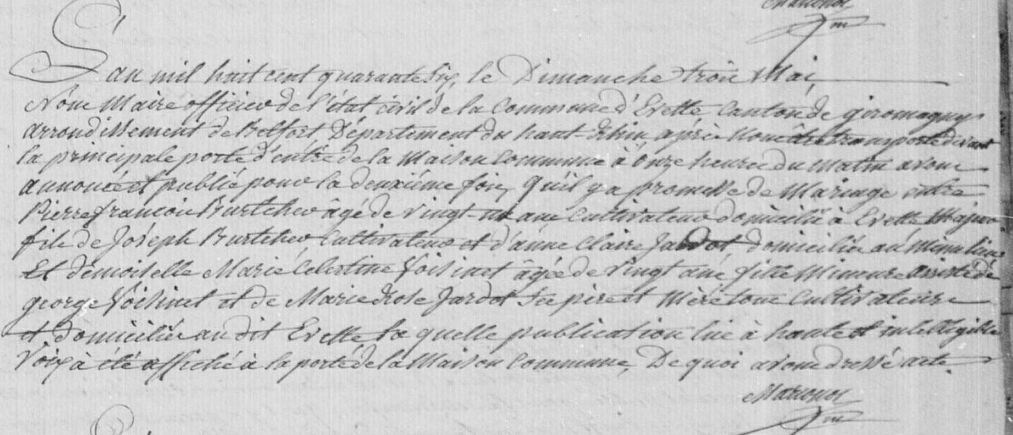
Burtcher-Voisinet Wedding publication (1846)
Image 494/783

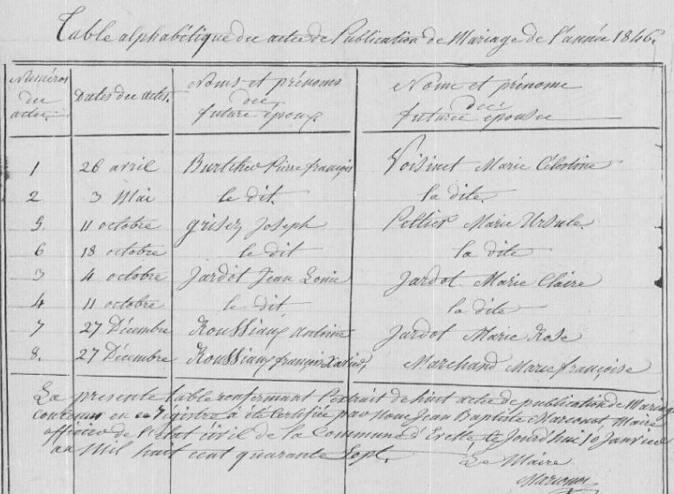
Burtcher-Voisinet Publication de Marriage
Image 496/783

