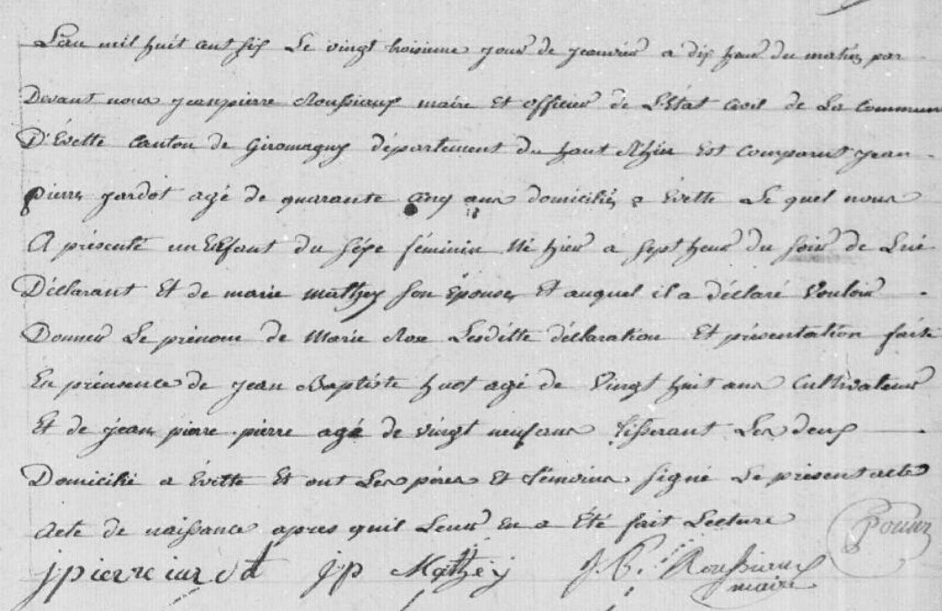
Civil Birth Record of Marie Rose Jardot
Source: http://www.archives.cg90.fr/?id=etat_civil
Evette, Births, Marriages and Deaths Cote 1 E 42, N.D.M. 1-3 1803-1869
Image 16/783

