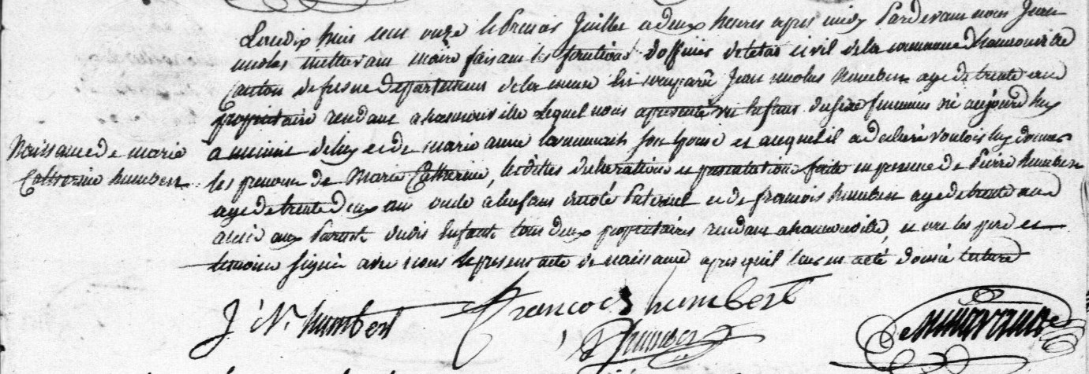
Birth Record of Marie Catherine Humbert
Source: http://archives.meuse.fr
Etat Civil
Hannonville-sous-les-Cotes
1802-1812, Births, Marriages, Deaths
Image 282/320

