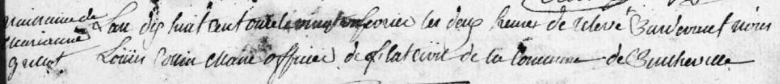
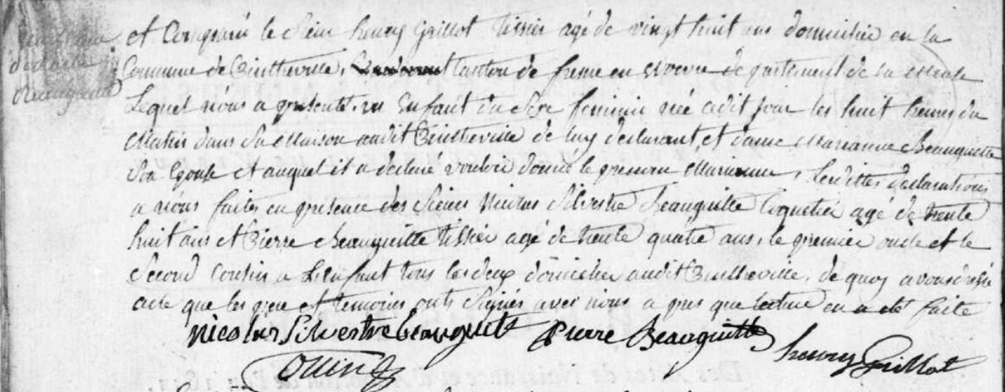
Birth Record of Marianne Grillot, daughter of Henry Grillot (brother of Louis Grillot)
Source: archives.meuse.fr
Etat Civil
Pintheville
1802-1812 Births, Marriages, Deaths
Images 73-74/91

