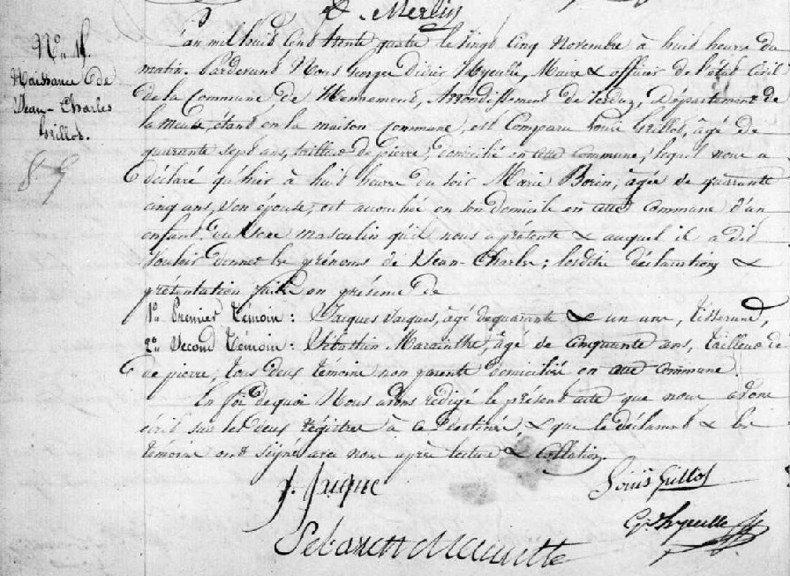
Birth Record of Jean Charles Grillot, son of Louis Grillot and Marie Borin
Source: http://archives.meuse.fr
Etat Civil Hennemont 2 E 250 (7) 1833-1842 Births, Marriages, Deaths Image 42/259

