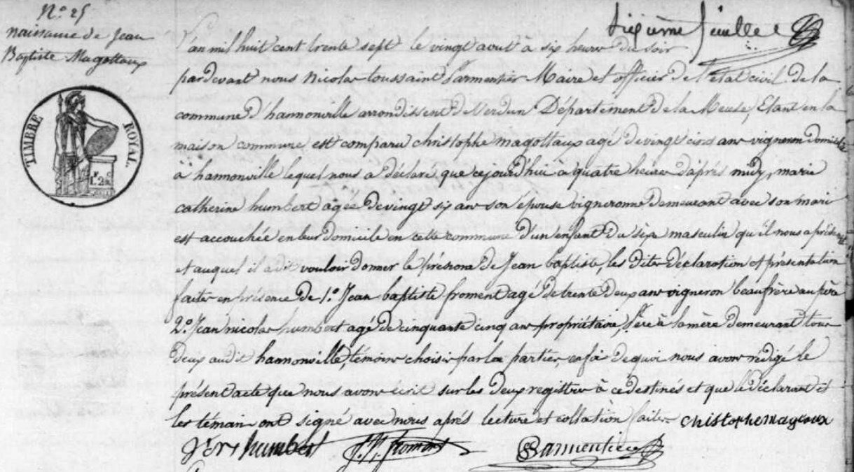
Birth Record of Jean Baptiste Magottaux, brother of Jules Francois Magottaux
Source: http://archives.meuse.fr
Etat Civil
Hannonville-sous-les-Cotes
1833-1842 Births Marriages Deaths
Image 221/447

