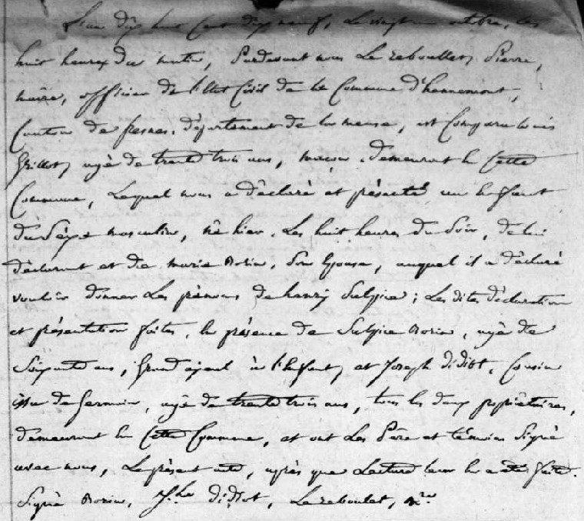
Birth Record of Henry Sulpice Grillot (1819-1886), son of Louis Grillot and Marie Borin
Source: http://archives.meuse.fr
Etat Civil Hennemont 2 E 250 (5)
Births, Marriages, Deaths 1813-1822
Image 74/115

