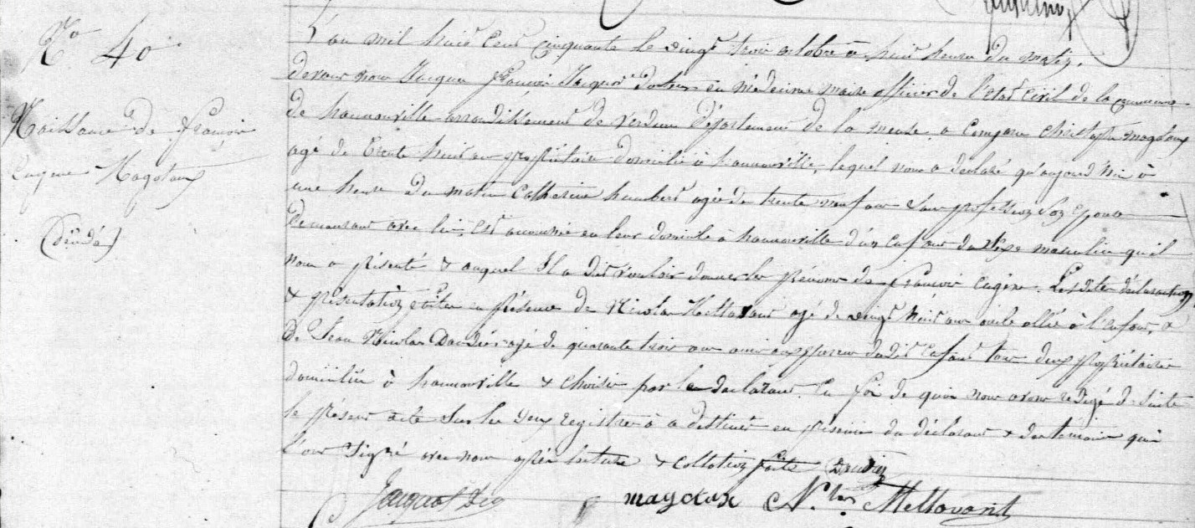
Birth Record of Francois Eugene Magotaux, brother of Jules Francois Magotaux
Source: http://archives.meuse.fr
Etat Civil
Hannonville-sous-les-Cotes
1843-1852 Births Marriages Deaths
Image 294/442

